POTATO
Sc. Name: Solanum tuberosum L.
Family: Solanaceae

Description
Potato, Solanum tuberosum, is an herbaceous perennial plant in the family Solanaceae which is grown for its edible tubers.
Morphology:
- The potato plant has a branched stem and alternately arranged leaves.
- The leaflets can be oval to oblong in shape and the leaves can reach 10–30 cm (4–12 in) in length and 5–15 cm (2–6 in) wide.
- The potato plant produces white or blue flowers and yellow-green berries. The potato tubers grow underground and generally located in the top 25 cm (10 in) of the soil.
- The tubers can range in color from yellow to red or purple depending on the variety. Potato plants can reach in excess of 1 m (3.3 ft) in height and are grown as annual plants, surviving only one growing season.
- Potato may also be referred to as, spud, Irish potato, white potato or Spanish potato and originates from South America.

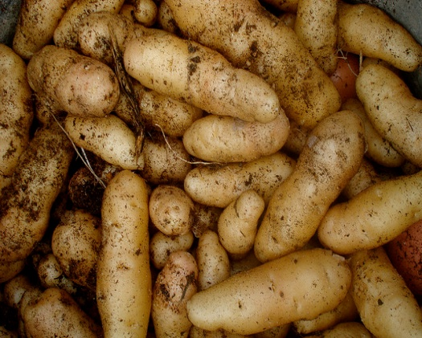

Uses
- Potato tubers are a staple food source in temperate regions and are eaten after cooking.
- They may be cut or sliced and made into potato chips or fries.
- Potatoes can also be processed into starch, alcohol or flour.

Propagation
Requirements Potatoes are cool season crops which grow best in cooler climates or as a winter crop in areas with warm summers. They are sensitive to heat but can tolerate a light frost. Potatoes require a deep, fertile, loose, well-draining soil with a pH between 5.8 and 6.5 and will grow optimally at daytime temperatures between 18 and 27°C (65–80°F) and night time temperatures between 12 and 18°C (55–65°F). Plants can also be successfully grown outdoors in burlap bags or large containers.
Seed pieces Potatoes are usually grown from seed potatoes. Small sections of a large tuber known as “seed pieces” or small seed potatoes can be used. Seed potatoes can be purchased from garden centers when in season and through seed companies. Each piece of planting material should have at least two eyes. The eyes are the area from which a shoot will sprout and after cutting should be allowed to cure for a few days prior to planting in the soil. Curing helps to protect the seed pieces from rotting as well as reducing the likelihood of a pathogen invading. Curing is very simple and can be achieved by laying out the seed pieces on paper towels and allowing to dry out for 3 to 4 days.
Planting Prepare soil for planting by working in compost or well-rotted manure. Potatoes are commonly grown in hilled rows. This involves digging shallow trenches 60–90 cm (2–3 ft) apart after the addition of the compost or manure. Space the seed pieces 30 cm (12 in) apart and cover with 7.5 cm (3 in) of soil. When the plants reach approximately 25 cm (10 in) in height mound the soil up around the stems of the plants so that they are covered up to about half of their height. This protects shallow tubers from turning green from exposure to sunlight. Allow the plants to grow another 25 cm (10 in) and again mound the soil. Continue this process for the duration of the crops growth. Straw can be used around the plants instead of soil which eliminates the need to dig for the tubers but care must be taken to add fresh the straw regularly as it will break down over time. Alternatively, potatoes can be grown in containers or burlap bags.
General care Potatoes are sensitive to soil moisture and grow best when soil moisture is consistent. The plants generally require about 1 inch of water a week from rainfall or irrigation. Water-satureated soil should be avoided as it can poorly formed tubers and rot. In addition, potatoes are heavy feeders and the addition of a balnced fertilizer every two weeks can help increase tuber yields.
Harvesting The time potato tubers take to reach maturity is variable and depends on the variety being grown, although it is usually about 2–3 weeks after the plants have bloomed. All tubers should be harvested when the vines have died or before a frost which will kill the plants. Harvest the tubers by gently digging them up with a fork or with your hands if the soil is loose enough. Harvesting is easier when the soil is dry. Do not wash the tubers prior to storing.

