Yellow vein mosaic / Vein clearing (Vector: White fly – Bemisia tabaci)

This is the most important factor limiting cultivation of okra (Ladies fingers: Abelmoschus esculentus) throughout India. This viral disease is prevalent wherever the crop is grown especially during the rainy season. If the plants are affected during the early stages of growth, there is a total loss of yield. If infection is found within 35 days of germination, the crop growth is retarded with very few leaves and fruits. Damage may be to an extent of about 94 percent. Plants infected at 50 and 65 days after germination suffer a loss of 84 and 49 percent respectively. The extent of damage declines with the delay in infection.  Symptoms  The major symptoms are vein clearing and veinal chlorosis of leaves. The yellow network of veins is conspicuous and the veins and veinlets are thickened. The veins turn yellow throughout the entire leaf blade. In cases of severe infection, the younger leaves are yellow in colour, reduced in size and the plant remains stunted. Leaves continue to show symptoms as they are formed, throughout the growing season. The infection prevents the formation of flowers and fruits. If formed, the fruits are small, malformed, hard and yellowish green in colour. Such fruits do not fetch a good price in the market. The conditionmay affect many plants in the field and may occur at any stage of the plant's growth. Varieties like Parbhani Kranti, Arka  Anamika, Arka Abhay, Janardhan and Haritha are reported to be tolerant to yellow vein mosaic. No known variety is reported to be completely resistant to the disease. | 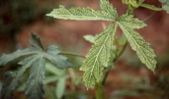
 | 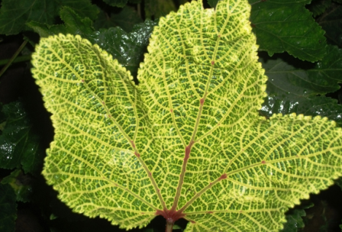
The causal agent
The disease is caused by the Yellow Vein Mosaic Virus (YUMA). But under experimental conditions, it has been transmitted by grafting. Not much is known about the nature and properties of this virus. It is transmitted by white flies (Bemisia tabaci) and the okra leaf hopper (Empoasca devastans). The wild hosts of the virus include rail weed (Croton sparsiflora), and goat weed (Ageratum sp).
Disease cycle
The insect vectors transmit the virus from wild hosts to the main crop. The disease is not seed borne. A continuous cycle is maintained through wild or cultivated hosts. Climatic factors favour the population build up of vectors and the prevalence of wild hosts.
Management
- Cut a cactus like nawagalli (Euphorbia nivulia) or milk bush (E. tirucalli) into pieces, immerse in water (just enough for the pieces to float), allow to ferment for 15 days, filter and spray.
- Control the vector by spraying 5% neem seed kernel extract or ginger, garlic and chili extract.
- Destroy weeds and other wild hosts wherever possible.
- Remove the affected plants from the field and burn them.
- Avoid summer season planting.
- Plant resistant varieties like Parbhani Kranti, Arka Anamika,
VRO-5, VRO-6 and Pusa A-4 (Co-2 is susceptible to YVM).

