**Unit 6: Enzymes** **(4 lectures)**

**Structure of enzyme: holoenzyme, apoenzyme, cofactors, coenzymes and prosthetic group; Classification of enzymes; Features of active site, substrate specificity, mechanism of action (activation energy, lock and key hypothesis, induced - fit theory), Michaelis – Menten equation, enzyme inhibition and factors affecting enzyme activity.**

Enzymes are commonly known as **biocatalyst** are unique and highly specific proteinaceous substances. These are produced by living system and have great ability to catalyse all the biochemical reactions in the living tissue with high degree of specificity and efficiency.

**Definition** – Enzyme can be defined as **“a substance of biological origin, which can alter the velocity of the chemical reactions without themselves undergoeing any apparent change during the course of its action.”** An enzyme can be extracted from the parent cell and it can perform similar catalytic reaction outside the biological system if similar condition is maintained.

**History** – the term enzyme was introduced by **Kuhne** in 1878. Edward Buchner, a german chemist, in 1897 while preparing for yeast extract could isolate as enzyme called Zymase that could breakdown of hexose sugars in fermentation, for which he was awarded **Nobel** prize in1907.

**Structure of enzyme: holoenzyme, apoenzyme, cofactors, coenzymes and prosthetic group**

Enzymes are proteinaceous in nature. They are giant molecules and their molecular weight rangesbfrom 35000 (pepsin) to 483000 (urease). Enzymes may entirely consist of protein (e.g. amylase, pepsin) or may contain a non-protein part. If an enzyme consists only protein, it is called simple protein enzyme and if it contains another group it is called conjugated protein enzyme. Euler (1932) proposed that conjugated enzymes showing complete activity be called ***holoenzymes***. These consist of two portions. The protein part of enzyme is called ***apoenzyme*** and the non-protein part is called ***prosthetic group*** or ***cofactor***. Thus both these apoenzymes and prosthetic groups together are called holoenzymes.

Depending upon the nature of prosthetic group, conjugated enzymes are of two categories

1. If the prosthetic group is an *inorganic ion* then it is called *cofactors*. e.g. ascorbic acid.
2. The prosthetic group is an *organic compound*, though at times inorganic ions may be present. The organic prosthetic group are called *coenzymes*. A coenzyme constitutes about one percent of the entire enzyme molecule. This part of the enzyme is more or less easily separable, usually heat resistant, often containing cyclic traces which may also accompanied by ribose and phosphate molecules. They have activating effects on enzymes.

Sometimes a nonprotein substance is required at the active centre for enzyme activity which is bound tightly to the enzyme protein by covalent linkages and is known as prosthetic group. The prosthetic group may consists of a) organic compound or b) simple metal ions such as Cu, Zn, Mn, Mo etc. the organic compounds acting as prosthetic groups are usually (i) flavin compound such as FMN (Flavin Mono Nucleotide), FAD (Flavin adenine Dinucleotide) (ii) iron-porphyrin or (iii) biotin etc.

**Nomenclature**

With the development of enzyme chemistry there has been a confusion in its terminology. **Duclaux** for the first time introduced a system of enzyme naming in 1883 on the basis of substrate on which it acts, followed by the suffix- **ase**, though there are many exceptions. In this system suffix **ase** is added to the root word to the substrate of the enzyme. For example, the name **sucrase** refers to an enzyme that causes breakdown of **sugar, sucrose**, similarly **cellulase** acts on **cellulose**, **protease** acts on **proteins** and so on. In another system of nomenclature of enzyme a suffix- **lytic** is added to the substrate such as **proteolytic** enzyme that catalyses **proteins**.

Enzymes are also named after the name of the **source from where they are extracted**. For example, **Papain** from **papaya**, **Bromalin** from **pineapple (Family- Bromaliacea**) etc. some enzyme are also named according to the **reaction they catalyse**. Thus, the enzyme which is responsible for **hydrolytic** **reaction** is known as **hydrolase**, **dehydrogenaqse** for **succinic dehydrogenase**.

This naming system was haphazard, therefore a systematic approach of naming the enzyme has been recommend by the **Commission on Enzyme of the International Union of Biochemistry (1961)** according to which the various enzyme are designated by **code numbers** of **four digit**.

The main features of the new system of classification of the enzymes as recommended by the **Commission on Enzyme of the International Union of Biochemistry (1961)** are as follows-

1. All the known enzymes have been grouped into 6 major classes.
2. Each major class has been divided into sub-classes.
3. Each sub-class has been furt her sub divided into sus-sub-classes.
4. Each enzyme has been assigned a specific code number consisting of four digit. The first digit indicates the major class, the second indicates the sub-class, the third digit indicates its sub-sub-class while the fourth digit denotes the systematic specific name of the enzyme the first part of which indicates the name of the substrate and the second part the nature of the reaction.

**Major class**

1. **Oxidoreductase**- Catalyse oxidation reduction reaction
2. **Transferase**- Catalyse reaction which involve group transfer
3. **Hydrolases**- Catalyse hydrolytic reactions
4. **Lyases**- catalyse reaction in which either double bond is established due to the removal of a group, or a group added to the double bond
5. **Isomerase**-catalyse isomerisation reactions
6. **Ligases**- catalyse those reactiob in which linking of two molecule is coupled with the breakdown of pyrophosphate bond of ATP or similar triphophate.

**Sub class**

1.1 Oxidoreductase, acting on the CH.OH group donor

2.1 Transferase, transferring one carbon groups

3.1 Hydrolases, acts on ester links

4.1 Lyases, acts on C-C bond

5.1 Isomerise, acts as racemase and epimerase

6.1 Ligases, , forms C-O bonds

**Sub- sub- class**

1.1.1 Oxidoreductase, acting on the CH.OH group donor, with coenzyme NAD or NADP as acceptor

2.1.1 Transferase, transferring one carbon groups, and a methyl transferase

3.1.1 Hydrolases, acts on carboxylic ester links,

4.1.1 Lyases, acts on C-C bond, carboxylase

5.1.1 Isomerase, acts as racemase and epimerase on amino acids and derivatives

6.1.1 Ligases, forms C-O bonds, amino acid-RNA ligase

For example

|  |  |  |
| --- | --- | --- |
| Code no | Systematic Name | Trivial Name |
| 1.1.1.1 | Alcohol NAD: Oxidoreductase | Alcohol dehydrogenase |

**Classification of enzymes**

Enzymes are classified into six main classes on the basis of their reaction specificity by the International Union of Biochemistry (IUB).

1. **Oxido-reductase** – These enzymes are concerned with biological oxidation and reduction. They are further classified into the following types-
2. **Dehydrogenase** - These enzymes are responsible for removal of hydrogen atom from one substrate to another substrate. Eg. **Alcohol dehydrogenase**.

Dehydrogenase

**AH2 A + 2[H] B**

**BH2**

1. **Oxidases** – The enzymes that catalyse the transfer of hydrogen to molecular oxygen are termed as oxidases.

Oxidase

**AH2 + ½ O2 A + H2O**

1. Oxygenase – These enzymes catalyse the incorporation of oxygen to the substrate.

Oxygenase

**H2O+ ½ O2  H2O2**

1. **Transferase** – Enzymes which are concerned with the transfer of a group of atoms from one molecule to another are called transferases. The transferase enzymes ususlly transfer carbon aldehyde or ketonic residues e.g. **Creatine phosphoryl transferase** of muscle cell. It transfer the energy rich phosphate group from creatine phosphate to adenosine diphosphate (ADP) to form adenosine triphosphate (ATP).

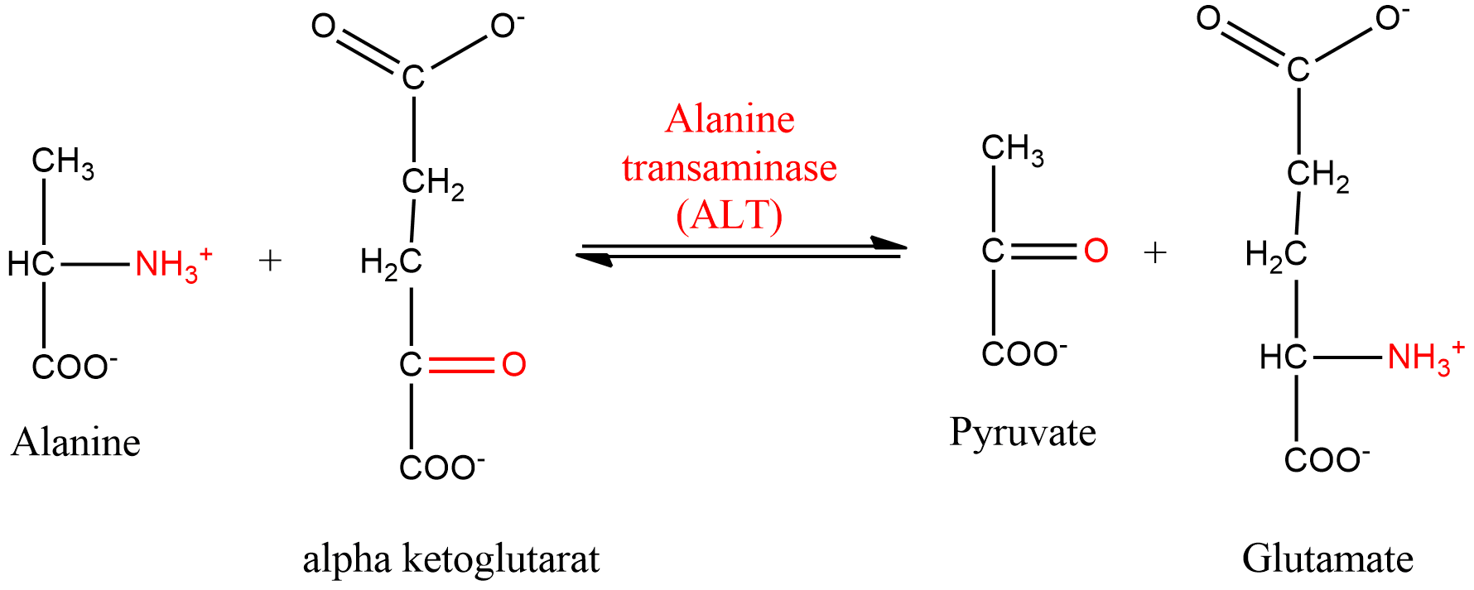

1. **Isomerases** – these enzymes are concerned with the catalytic reaction of intramolecular rearrangement of atoms in their substrate i.e. they catalvse different types of isomerisation reactions. E.g. Phosphohexose isomerise.

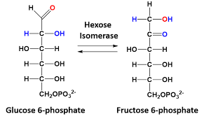

1. **Hydrolases** – these enzymes are concerned with the hydrolysis of complex molecule into simpler forms reacting with water. These are usually named on the basis of substrate they hydrolase. Thus, these are classified into following types-
2. **Proteases** – these are concerned with breaking down of peptide bond of protein into peptides to convert them into amino acid.
3. **Carbohydrases** – These catalyse the hydrolysis of carbohydrate into simpler forms. E.g. **Maltose, Lactose, Salivary amylase** etc.
4. **Esterases** – These enzymes catalyse hydrolysis of ester linkage. E.g. Lipases, Phosphatases etc.

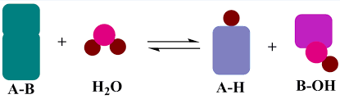

1. **Lyases** – Lyases are concerned with the breakdown of complex substances into simpler forms but without hydrolysis e.g. **deoxycarboxylase**.

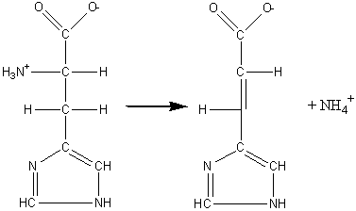

1. **Ligase or synthetase** – these catalyse the linkage of two separate molecules. Eg. **Acetyl CoA carboxylase**.

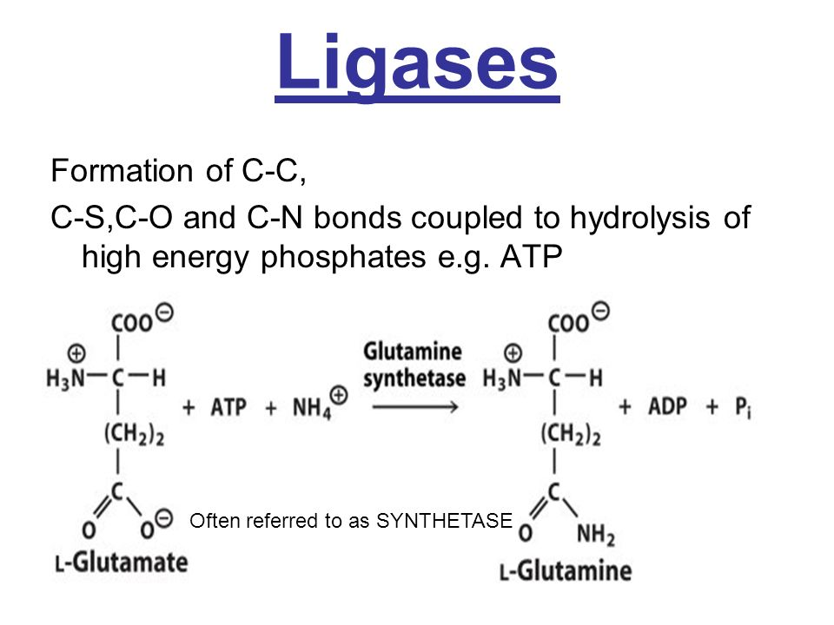

**Chemical properties of enzyme**

1. **Catalytic properties** – Enzymes are biocatalyst. They have enormous ability to catalyse. A small amount of enzyme can catalyse large amount of substrate but at the end of the reactions it remains unchanged.
2. **Specificity of enzyme** – An enzyme is a specific in its action i.e. a particular enzyme can act only upon certain substrate or a group of substrates thus, maltase acts on maltose no other substrate, this means that there should be separate enzymes for separate substances. The specificity of an enzyme determined by its configuration which will fit only the configuration of a particular type of substrate molecule in the same way that a key fits only one type of lock.
3. **Solubility** – Enzymes are soluble in water, alcohol, saline and also in dilute glycerine.
4. **Reversibility in action** – Enzymes can accelerate the biochemical reactions in neither directions.
5. **Sensitivity of enzyme** –
6. The enzymes are very sensitive to heat i.e., they are thermolabile. They are inactivated at very low temperatures. At very high temperatures 60-70°C usually they are destroyed (denatured). Low molecular weight enzymes are comparatively more heat stable.
7. Enzymes are also sensitive to inhibitors. While some inhibitors may partially inhibit their activity, other inhibitors like poisons destroy them permanently and inhibit their activity.
8. Enzymes also show great sensitivity to pH. Change in pH causes decreases of enzyme activity. Enzymes have optimum pH range for their best activities. For example, ptyalin or salivary amylase can perform its best activities in slightly acidic medium in buccal cavity but its acivity is lost in the stomach due to high acidic pH.
9. **Colloidal properties** – Enzymes are proteins, hence, they form colloidal solution in water. For their large size, the enzymes can diffuse but very slowly, therefore enzymes can easily be separated by dialysis.

**Mechanism of action (activation energy, lock and key hypothesis, induced - fit theory)**

In the metabolic process, when an enzyme catalyses a substrate molecules must come in contact with specific enzyme to ensure an enzymatic reaction. To explain this enzyme substrate relationship several workers gave theories, the most accepted theories are

1. **Activation energy - Arrhenius** first pointed out that all the molecules in a given population do not have the same **kinetic energy**. Some molecules due to collisions have more energy and are energy-rich molecules while others are **energy-poor molecules**.

In an ordinary chemical reaction only energy-rich molecules can take part at normal temperature due to an **energy barrier** to reaction and hence, the rate of reaction is lower. The higher is the energy barrier for a molecule, the greater is its stability (or inactiveness to take part in reaction). The energy required to hurdle molecules over this energy barrier is called as the **energy of activation**.

At higher temperature the rate of chemical reaction becomes faster because increased temperature bring about an increase in the number of **activated molecules** by increasing their movement and number of collisions due to **thermal agitation**.

But, in case of **enzyme catalysed reactions** the rate of reaction is **optimum** at normal body temperatures. It is because all the molecules (energy-rich and energy –poor) can combine with the active sites of enzyme to form **enzyme substrate complex** which later on breaks into enzyme and the product. In other words, the enzymes act by **lowering the energy of activation of the reactions.**

The most important role which enzymes play during reaction is that ‘**they lower down the energy of activation**.’ Suppose A is spontaneously getting converted into B, firstly in absence of an enzyme and secondly in presence of an enzyme, in a given number of molecules of A at a specific temperature, they have certain kinetic energy – some are poor in energy and others are rich. Before converting A B, the molecules of substrate A must surmount a required kinetic energy. The kinetic energy of A is higher than B. so only few energy-rich molecules can get converted into product B. **The energy that is required for A to react and get converted into B is called the activation energy of reaction**.

An enzyme will lower the activation energy of reaction. The enzyme reacts with the energy-rich and energy-poor molecules and forms an intermediate complex. This complex again breaks into product and enzyme. If the activation energy of the formation of this way activation energy is lowered by the enzyme, but in this action equilibrium is never altered. It remains the same.

1. **Lock and Key theory** – This theory was proposed by Fischer in 1898. According to him the larger enzyme molecule comes in contact with smaller substrate molecule to form complex called “ Enzyme – substrate – complex. “ Enzymes bear distinct areas or sites in which specific type of substrate molecules can fit and form an intimate association. The configuration of a specific enzyme is specifically designed so as to fit the enzyme molecule, so that, the two can work together like that of a key to lock. Thus the enzyme substrate reaction can be written as

**Enzyme [E] + Substrate = Enzyme-substrate-complex [E - S complex]**

**Or**

**E + S = E-S – Complex**

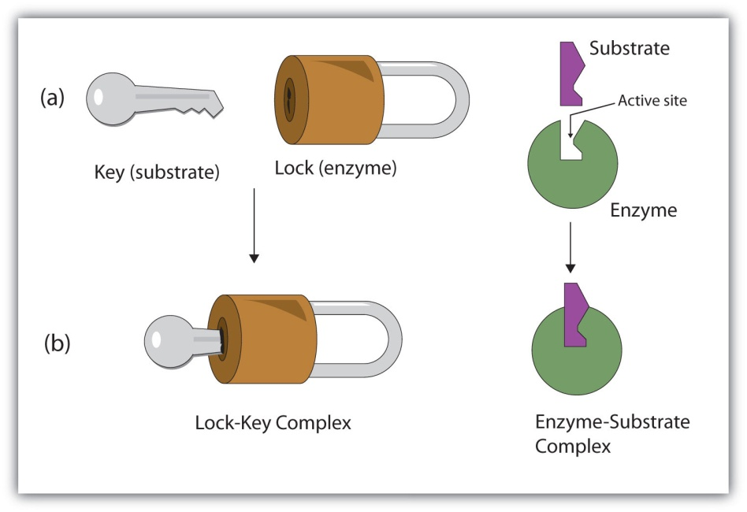

Fig : Lock and key model of enzyme action

The “enzyme-substrate complex” is believed to be much less stable than the original substrate and so, they breakdown immediately, the enzyme being again liberated. The substrate is converted into products.

**Enzyme- substrate – complex [E-S complex] = Enzyme [E] + product [P]**

**Or**

**E - S – complex = E + P**

According to this theory the enzyme- substrate relationship can be compared with the working of a pair of lock and key. Because particular key can fit to a particular lock to be opened and similarly a particular enzyme can fit to a particular substrate to their specificity.

1. **Induced - fit theory –** This theory was proposed by Koshland in 1959.According to this theory, the catalytic sites or the active sites of an enzyme are not pre-shaped to fit the substrate as suggested by Fischer. Rather, the substrate molecules induce a conformational change in the enzyme. According to Koshland, the active sites of some enzymes are flexible but not rigid. The configuration of the active sites is complementary to that of the substrate only after the enzyme – substrate – complex is formed

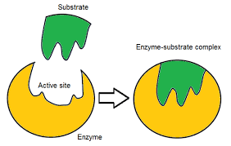

Fig : Induced Fit model of enzyme action

**Michaelis – Menten equation,**

In an enzyme catalyzed reaction when there is large excess of substrate and the enzyme concentration is held constant, if substrate concentration in plotted against velocity (V) or reaction rate, a hyperbolic curve is obtained. This type of plot is also known as saturation plot. In the beginning, there is approximately direct proportionality between substrate concentration and reaction rate until the enzyme concentration becomes limiting and a steady state is obtained. In this situation addition of more substrate will not increase reaction rate because all the active sites of the enzyme are saturated with substrate molecules and the rate of reaction will increase only by addition of more enzyme.

Michaelis and Menton (1913) while studying the hydrolysis of sugar by invertase evolved a theory on the mode of enzyme action. They considered that enzymes have certain active sites for the attachment of substrate molecule where an enzyme can form an intimate relationship with the substrate. According to the theory an enzyme forms a weakly bound compound with substrate which on hydrolysis decomposes into the reaction products.

In simple form theory can be represented as follows:

Enzyme + substrate Enzyme – substrate End products + enzyme complex.

They applied equation kinetics of enzyme while discussing about the mode of action. It can be explained as follows.



(Where E= enzyme, S= substrate, ES=enzyme-substrate complex, K1= velocity constant of the formation of ES and K2= velocity constant of dissociation of ES)

Or



(Where K3= velocity constant of decomposition of the complex and P = end product)

Considering these facts Michaelis and Menton derived the following formula

Km= K2-K3/K1

This Km is known as **Michealis constant**. Km value is characteristic for each enzyme substrate system and if the same enzyme attacks more than one substrate, its value gives useful comparison of the relative affinities for the different substrates. Lower the Km value more the affinity. When velocity of reaction is half of the maximum velocity, Km is equal to the concentration of the substrate. Substrate concentration is expressed in moles per litre.

Michealis and Menton theory has not been found universally true, though recently intermediate enzyme-substrate compound from the reaction mixture has been isolated.

The concentration of substrate required to half saturate the enzyme or in other words to cause half the maximal reaction rate (1/2 Vmax) is called **Michealis constant or Michealis and Menton constant**. Michealis constant is a reflection of the affinity of enzyme for its substrate and is characteristics of a particular enzyme-substrate system. **The smaller the value of Km, the more strongly the enzyme binds the substrate.** An enzyme that catalyzes a reaction between two or more different substrate has different Km value for each of the substrate.

Although Km values are more or less constants for particular enzyme-substrate system, but these may vary slightly with pH, temperature, ionic strength and also with types and amount of enzymes when required for the reaction.

The values of Km are measured in terms of **molarity**, typically, the values of Km for most enzyme studied so far range between 10-3 to 10-6 molar (1mM-1µM).

**Significance**

There are many advantage of knowing the Km values of enzyme-substrate systems,

1. By knowing the Km value of a particular enzyme-substrate system, one can predict whether the cell needs more enzymes or more substrate to speed up the enzymatic reaction.
2. If an enzyme can catalyse a reaction with two similar substrate (e.g., glucose and fructose) in the cell, it will prefer that substrate for which the enzyme has lower Km value.
3. Km value gives an approximate measure of the concentration of substrate of the enzyme in that part of the cell where reaction is occurring. For instance, those enzymes which catalyse reactions with relatively more concentrated substrates (such as sucrose), usually have relatively high Km value. On the other hand, the enzymes that react with substrates which are present in very low concentrations (such as hormones) have comparatively lower Km values for the substrate.

**Enzyme inhibition**

There are certain products which inhibits the enzyme activity e.g. presence of malonate (inn krebs cycle) inhibits the activity of succinate dehydrogenase. These substances are called inhibitors and are following types

1. **Competitive inhibitors**- Competitive inhibitors usually have structure sufficiently similar to the substrate that they are able to compete for the active site of enzyme.

The active site of enzyme is fitted with molecules of other substance which are similar to those of the substrate. So the activity of enzyme is lost. E.g. in case of succinic acid and malonic acid, either one can fit with enzyme-FAD.

1. **Non-competitive inhibitors**- in contrast to the competitive, these never compete with active sites of enzymes. In this case inhibitors react with either parts of enzymes not involved in catalytic or active site. These inhibitors do not show structural resemblances with the substrates. Toxic metal ions and compounds that destroy essential sulfhydryl groups (e.g. excess oxygen) are examples of non-competitive inhibitors.
2. **Allosteric modulation**- The activities of some enzymes are regulated internally. Some specific low molecular weight substances, such as products of another enzyme of the same metabolic pathway, act as inhibitors. Such substances bind with a specific site of the enzyme different from its substrate binding site, and thus alter the shape of the enzyme and decrease the enzyme action. Such enzymes are called allosteric enzyme, e.g. hexokinase which changes glucose-6-phosphate. Glucose-6-phosphate inhibits the hexokinase activity. It may also be called allosteric inhibition **or Feedback Inhibition**.

**Factors affecting enzyme activity**

There are several factors influencing enzyme activity. The best known factors are

1. **Temperature** – temperature is the most important factor which controls effectively the rate of enzymatic reactions. At 0°C, the rate of an enzymatic reaction is practically zero. Normally, the rate of the reaction increases with the rise in temperature but there is a limitation. The rate of the enzyme catalysed reactions do not, however, increase indefinitely as the temperature is increased. At a certain point the reaction is completely stopped, and thus, comes to an end. Thus happens because the high temperature destroys the catalytic function of the enzyme. The enzyme which is a protein becomes denatured (inactive) on heating.
2. **Hydrogen ion concentration** – Enzymes are very restricted in their activities by the change of hydrogen concentration (pH) of the medium in which they are working. The optimum pH is changeable fromm enzyme to enzyme. Generally, the pH values for the enzymatic reaction vary from pH 1.5 to 10.0.

An enzyme can perform its best activity at a particular pH value of the medium in which it is working. Its activity declines gradually on either side of the optimum range.

1. **Concentration of enzyme** – t he rate of enzymatic reaction increases proportionally with increasing concentration of the enzyme provided the substrate is available in the medium and pH, temperature and other conditions are not limiting.
2. **Concentration of the substrate** – The increase in the concentration of the substrate causes an increase in the rate of reaction upto certain limiting value, beyond which there is no increase inn the reaction.
3. **Concentration of the end products** – In the enzymatic reactions, the substrates are broken, catalysed into products but, like all chemical reactions, the active accumulation of the end products will cause a decrease in the reaction rate. The rate of an enzymatic reaction, thus, depend on the speed with which the products are rremoved from the site of production.
4. **Co**-factors – some enzymes cannot act on their substrates unless there are certain assisting non-protein components called co-factors. These are activators of enzyme. Example: Mn, Ni,Mg.
5. **Inhibitors** – the substances which when present in the reaction site decrease the rate of enzymatic reactiojnare called inhibitors. Examples: salts of heavy metals, trichloroacetic acid.

Inhibitors are of two types-

1. **Competitive inhibitors**: These inhibitors have structural analogue and hence compete with the normal substrate-complex.
2. **Non-competitive inhibitors**: In case of non-competitive inhibitors, the inhibitor and the substrate are not structurally related, they can react with the enzyme, thus inactivating the enzyme-substrate-complex.

**Economic Importance of Enzyme**

Enzymes have been found playing very important role in several industrial processes. In some cases, the hydrolytic activities of living cells have been employed while in other cases, some enzymes are extracted from living cells and then allowed to act upon certain substances. The following uses substantiate their importance in industries. These are used in

1. The preparation of sizing for textile and paper.
2. The removal (retting) of fibres from the stems of flax, hemp and other plants.
3. The degumming of silk
4. The preparation of skin for tanning
5. The manufacture of glycerine
6. The brewing and clarification of beer
7. The clarification of syrups and pectin solutions
8. The making of bread
9. The cheese manufacture
10. The production of syruos from sweet potato and corn
11. The manufacture of soy sauce
12. The fermentation of pulp to remove it from cocos seeds
13. The preparation of medicinal diastase, pepsin and papain
14. The processing of tea and coffee, etc.