Alternation of generations
The life cycle of archegoniates is very interesting. It is split up into two phases, each represented by a separate adult. Thus in life cycle there occur two distinct multicellular, vegetative individuals. One of these is the green thalloid (liverworts) or leafy (mosses) plant. The other is the sporogonium. The green individual is an independent plant.
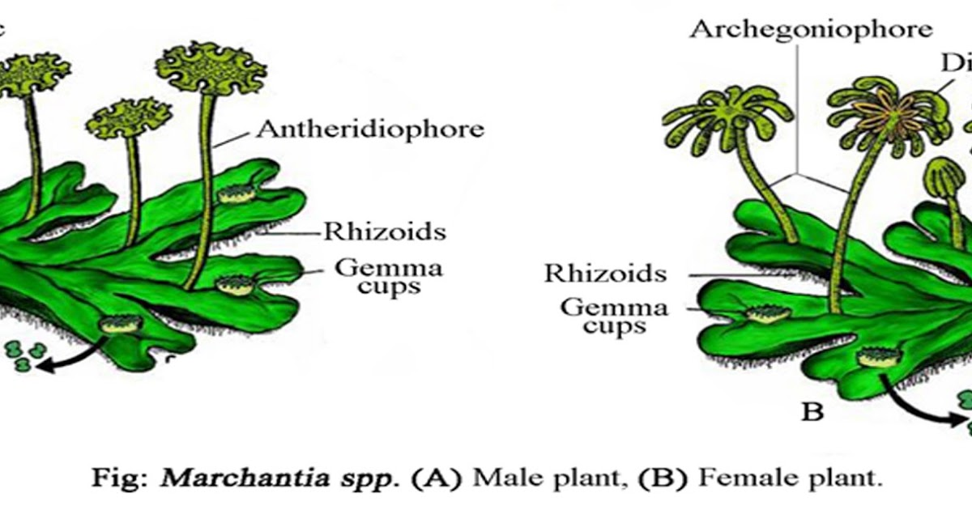
It is haploid and bears the sex organs (antheridia and archegonia) which produce the gametes (sperm and eggs). As it bears the gametes the green, independent individual is called the gametophyte. It is concerned with sexual reproduction. The gametophyte plant along with the structures produced by it constitutes the gametophytic generation. In the life cycle it starts with the information of meiospores and consists of the green individual and the sex organs. The last structures formed during this phase are the gametes. The gametes fuse to form the zygote.
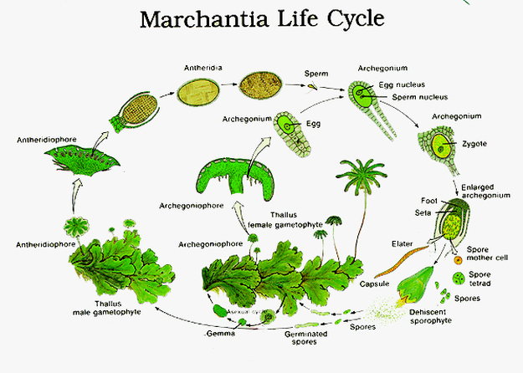
Fig: Alternation of generation of Archegoniates

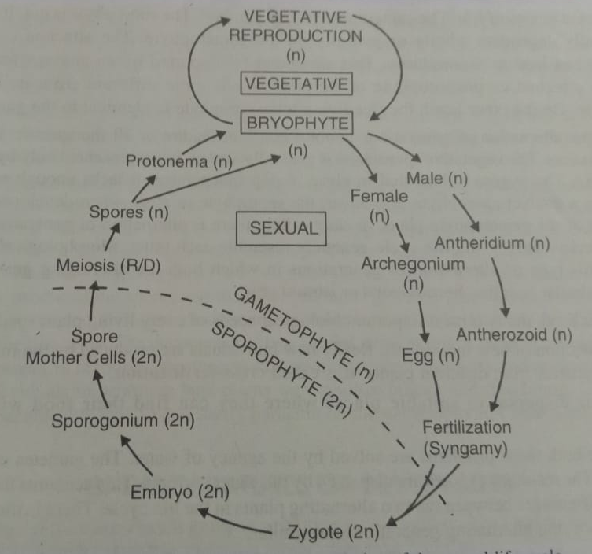
Fig: Diagramatic representation of alternation of generation of Archegoniates

The zygote, on germination, doesnot produces the gametophyte plant. It undergoes segmentation to form an embryo. The embryo by further segmentation and differentiation gives rise to the second adult called the sporogonium. It remains diploid and is usually differentiation into foot, seta and capsule. In due course of time, the diploid spore mother cells produced in the capsule give rise to haploid spores (meiospores) by meiosis. As the sporogonium is concerned with the production of spores it is called the sporophyte. The zygote, the embryo and the sporogonium together constitute the sporophyte generation. Moreover, it is dependent for its nutrition wholly or partially on the gametophyte plant to which it is attached organically throughout its life. On germination each spore produces a gametophyte and not a sporophyte plant.
From the account given above it is evident that on germination the reproductive cells of one generation give rise to the alternate generation in the life cycle. The two generations thus regularly alternate with each other in a single life cycle. This biological phenomenon is called alternation of generations. It is defined as the alternation in the life cycle of two distinct vegetative individuals with different functions. Cycles of this type characterized by alternation of generation and sporogenic meiosis are termed diplohaplontic life cycles.
In archegoniates alternation of generations becomes as integral part of the life cycle. Moreover, the alternating individuals in the life cycle of archegoniates are morphologically dissimilar. They differ not only in their structure but also in their physiology (nutrition). This kind of alternation of generations in which the alternating individuals are dissimilar is called heterologous or heteromorphic. The gametophyte is independent. The sporophyte is not. It is attached and generally dependent wholly or partially on the gametophyte.

