Morphology
Morphology is the name given to the science that deals with the study of the form and structure of things. No matter which plant you take, the morphology of a flowering plant includes the roots, stem, leaves, flowers, and fruits.

Flowering Plants
Flowering plants are the most diverse group of land plants with 300,000 known species. These are also known as angiosperms and produce seed-bearing fruits. It is believed that the flowering plant evolved from gymnosperms during the Triassic period and the first flowering plant emerged 140 million years ago.
Flowers are the reproductive organs of the flowering plants and the most important feature that distinguishes them from other seed plants. These have led to the speciation of angiosperms that helps them to adapt to diverse ecological niches.
The flowering plants reproduce by the process of pollination. In this, the pollen grains transfer from the anther of the male flowers to the stigma of the female flower where fertilization occurs and seed is formed.
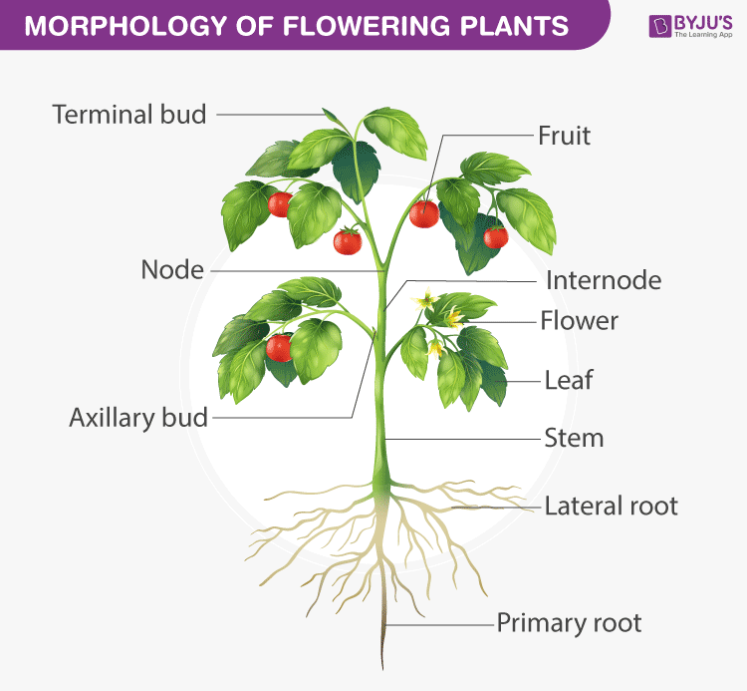
When we look into the morphology of flowering plants, a plant has two systems root system and shoot system. The underground part is called the root while the one above is named the shoot.

Root System
The root is a brown, non-green and underground part of a plant. Root with their branches is collectively called a root system. There are three types of the root system:
- Taproot System
The taproot is mainly found in dicotyledonous plants. It develops from the radicle of the germinating seed, along with its primary roots and branches, giving rise to the taproot system. Mustard seeds, mangoes, grams and banyan are a few examples of dicotyledonous plants with taproot system.
- The Fibrous root System
The fibrous root is mainly found in ferns and in all monocotyledonous plants. This root develops from thin, moderately branching roots or primary roots, growing from the stem. The fibrous root system usually does not penetrate deep into the soil, therefore, on full maturity, these roots look like a mat or a carpet on the floor. Wheat, paddy, grass, carrots, onion, grass are a few examples of monocotyledonous plants with the fibrous root system.
- The Adventitious root System
The roots which originate from any part of the plant body other than the radicle is called the adventitious root system. This root system is mainly found in all monocotyledonous plants. In plants, the adventitious root system is used for various purposes, like mechanical support, vegetative propagation, etc. Banyan tree, maize, oak trees, horsetails are a few examples of monocotyledonous plants with the adventitious root system.

Functions of Root
General functions of a root include:
- Storage.
- Anchorage.
- Absorption of water and minerals.

Regions of Root
The three regions of a root are-
- The Root Cap.
- The region of maturation.
- The region of Elongation.

Shoot System
Another essential part of the plant is its stem. It is the ascending part of the plant axis which bears branches, leaves, flowers, fruits and helps in the conduction of water and minerals. It is the aerial part of the plant, developed from the plumule of an embryo or the germinating seeds.
Young stems are usually green in colour and subsequently becomes woody and brown. The stem is modified into certain structures according to the function they perform.

Characteristics of Stem
Some of the important characteristics of the stem are:
- The stem develops from the plumule and epicotyl of the embryo.
- The stem is erect and grows away from the soil towards the light.
- There is a terminal bud at the apex of the stem.
- In angiosperms, the shoot is differentiated into nodes and internodes.
- Young stems are green and photosynthetic.
- Multicellular hair is present.
- The stem and branches of mature plants bear fruits and flowers.

Different forms of Stem
The stem is modified into the following different forms:
- Suckers.
- Runners.
- Climbers.
- Tubers.
- Rhizome.
- Tendrils.
- Thorns.
- Cladode.

Leaves
The leaf is a laterally borne structure and usually flattened. It is the main photosynthetic part of the plants. It absorbs light and helps in the exchange of gases through the stomata.
The main parts of the leaf include the leaf base, petiole, and lamina. They grow at the node and bear a bud at the axil. The arrangement of veins and vein-lets in a leaf is called venation. The leaves are green because of the presence of the photosynthetic pigment called chlorophyll and have a tiny pore or opening called stomata, where the gaseous exchange takes place.
Leaves can be further classified into simple and compound leaf, which are based on the pattern of a leaf blade. There are other types of leaves and are classified based on their shapes, arrangements of leaves, and Venation.

Characteristics of Leaves
- The leaf arises from the node.
- It is exogenous in origin.
- It has a bud at its axis.
- The growth of the leaf is limited.
- The leaves do not bear an apical bud.

Modifications of Leaves
Leaves are modified according to the functions they perform. The different structural forms of leaves include:
- Leaf Tendrils.
- Spines.
- Storage Leaves.
- Insect-catching leaves.

Functions of Leaves
Some of the important functions performed by leaves are:
- Photosynthesis.
- Transpiration.
- Storage.
- Guttation.
- Defence.

Flowers
The flowers are the reproductive part of the plant. The arrangement of flowers on the floral axis is called inflorescence, which has two major parts called racemose which let the main axis continue to grow and cymose which terminates the main axis in a flow.
The flower consists of four different whorls:
- Calyx, the outermost.
- Corolla, composed of petals.
- Androecium, composed of stamens.
- Gynoecium, composed of one or more carpels.
The reproduction in plants occurs by the process of pollination. It is the process of transfer of pollen from the anther to the stigma of the same or different plants.

Functions of Flowers
The flower performs the following important functions:
- They help in the process of reproduction.
- They produce diaspores without fertilization.
- The gametophytes develop inside the flower.
- The flowers attract insects and birds which then act as a medium to transfer the pollen from the anther of one flower to the stigma of some other flower.
- The ovary of the flower develops into a fruit that contains seed.

Fruits
The fruit is the characteristic feature of flowering plants, which is a ripened or mature ovary and the seed is what the ovules develop into after fertilization. The fruit that develops without fertilization is known as parthenocarpic.
Also Read: Anatomy of Flowering Plants

Types of Fruits
There are three different types of fruits and are classified mainly based on their mode of development.
- Simple— Developed from the monocarpellary ovary or multicarpellary syncarpous ovary. Examples of simple fruits.
- Aggregate–Developed from the multicarpellary apocarpous ovary. Examples of aggregate fruits.
- Composite–These are false fruits, developed from the entire inflorescence rather than from single flower. Examples of composite fruits include blackberries, Raspberries strawberries, etc.

The Seed
A seed is a basic part of a plant, which is found enclosed within the fruit. It is made up of a seed coat and an embryo. During the development of the fruit, the wall of the ovary becomes the pericarp. In some plants, the ovary wall dries out completely, while in some it remains fleshy.

Types of Seeds
Based on the number of cotyledons, seeds are further classified into two types- dicotyledonous and monocotyledonous seeds.
- Monocotyledonous— The embryo consists of an embryo axis and has only one cotyledon. The monocotyledonous is also known as monocot seeds. Grains including rice, millet, wheat and other plants like onions, corn, ginger banana, palm tree, are examples of monocot seeds.
- Dicotyledonous— The embryo consists of an embryo axis and has two cotyledons. The dicotyledons are also known as dicots or dicot seeds. Legumes including beans, lentils, pea, peanuts, and tomato are examples of dicot seeds.

