Ginkgo
Classification (up to family)
The genus belongs to the family Ginkgoaceae, order Ginkgoales and division Coniferophyta of Gymnospermae.
Distribution
There are only one living species by the name biloba under the genus Ginkgo. Ginkgo biloba is mostly confined to some parts of China and Japan. This species is now being cultivated as ornamental plant throughout the subtropical and temperate regions of the world. In India, this plant is found as cultivated ornamental plant in the hills viz. Darjeeling, Dehradun and Mussoorie.
Ginkgo biloba is commonly called maiden-hair tree because the leaves of G. biloba look like the leaves of maiden-hair fern i.e. Adiantum sp.

Morphology
Ginkgo is a tall and branched tree. The plant habit looks like a conifer and attains a height of 27-30 m.
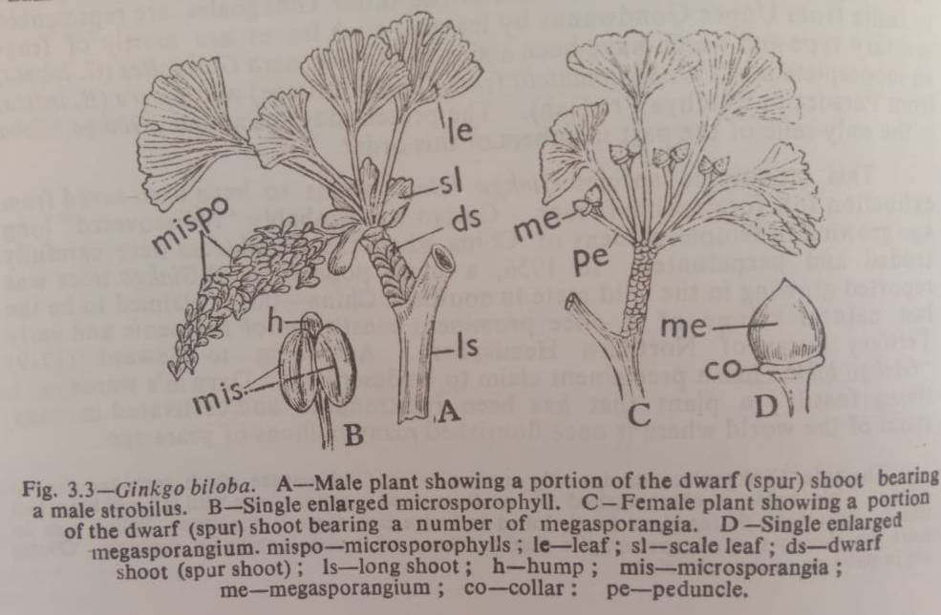
Stem
The branches are irregular and dimorphic in nature i.e. axillary long and dwarf i.e. short branches (shoots) occur. The long shoots bear branches of limited growth i.e. the so called dwarf or spur shoots. The long shoots grow rapidly while the dwarf shoots grow slowly. The dwarf shoot possesses a crown of foliage leaves at the apex and leaf-scars near the base.
Root
In Ginkgo, the root is a long tap root which penetrates deep into the soil.
Leaves
The leaf is very characteristic in form and in venation. The leaves are large and petiolate, broadly reniform to wedge-shaped (fan-shaped) in outline. Often more or less lobed with the forked (dichotomous) veins resembling somewhat the leaves of maiden-hair fern. Petioles are long slender. The leaves are covered with leaf scars and often scale leaves, but leaves remain scattered on the long shoots. The leaves which arise on the long shoot are deeply lobed and generally each splits into two, hence the specific name is biloba.

Anatomy
Stem
The stem of Ginkgo shows in transverse section a small pith and a thin i.e. small cortex. Pith is surrounded by a ring of endarch vascular strands forming siphonostelic cylinder. Mucilage canals, tannin cells and crystals of calcium oxalate are found widely distributed in the pith as well as in the cortex.
The stem of long and dwarf shoots differ anatomically, the stem of long shoot has a comparatively smaller pith and cortex, the secondary wood is harder and more well developed, and xylem rays are shorter, the stem of dwarf shoot has larger pith and cortex, and has many more mucilage canals. Vascular bundles are collateral. Primary xylem are provided with circular bordered pits, the secondary xylem is pycnoxylic. Uniseriate wide parenchymatous medullary rays are present. Periderm development is also noted.
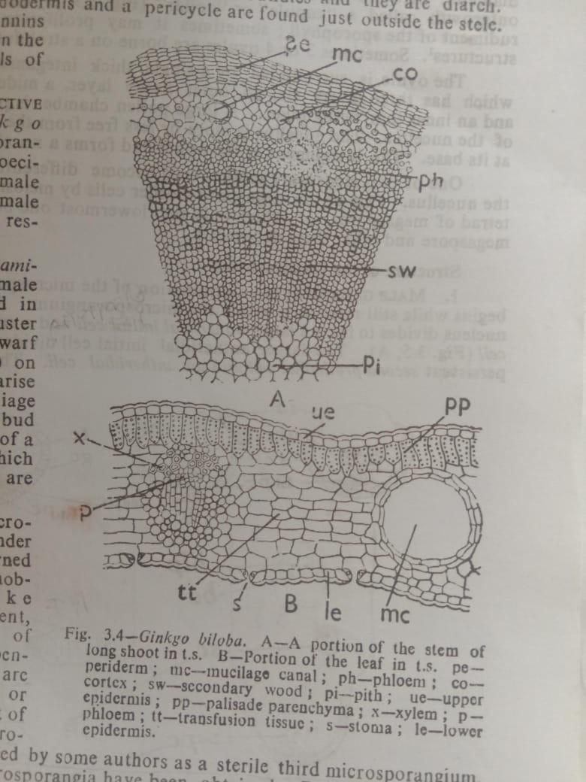

Root
The roots possess radial vascular bundles and they are diarch. Large cortex, an endodermis and a pericycle are found just outside the stele. Mucilage canals, tannins and starch occur in the parenchymatous cells of the cortex.
Leaves
Mesarch budles are noted in the cotyledons of the seedlings, but in the mature leaves this character is lost. Generally two exarch, collateral, vascular bundles surrounded by a sheath enter each petiole and dichotomous in the veins.
The leaves of long shoot possess palisade cells. Palisade cells are absent in the leaves of the dwarf shoot.
The upper epidermis is continuous, single layered and without stomata. Lower epidermis is provided with stomata irregularly scattered between the veins-stomata are haplocheilic. The lower mesophyll parenchyma cells are transversely elongated and arranged parallel with the epidermal layers. They are called transfusion tissue. Palisade parenchyma is present just below the upper epidermis. Vascular bundles are closed and collateral. Prominent mucilage canals are present.
Rreproduction of Ginkgo
Ginkgo biloba is monosporangiate and strictly dioecious. Male and female strobili occur on male and female plants respectively.
Male i.e. staminate strobilus
The male strobilus is formed in loose catkin-like cluster cluster at the apex of dwarff shoot on male plant. They arise in the axils of foliage leaves or inner bud scales. It consists of a central axis upon which microsporophylls are arranged spirally.
A mature microsporophyll has a slender stalk which is turned afterwards into a knob-like or hump-like enlargement, beneath one side of which usually two pendent microsporangia are borne. The hump or knob-like enlargement of the stalk of the microsporophyll is considered by some authors as a sterile third microsporangium. Sometimes 3-4 microsporangia have been obtained. Development of the microsporangium is of eusporangiate type. From the archesporial cell, primary wall cells and the sporogenous cells are formed. The sporogenous cells i.e. sporogenous tissue by repeated divisions form the microspore mother cells. Microspores i.e. pollen grains are formed from the microspore mother cells by reduction division. Microsporangia dehisce through longitudinal slit. Each pollen grain is surrounded by an inner intine and an outer exine. Due to incomplete nature of the exine two lateral ears are seen coming out from the pollen grain.
Female i.e. ovulate strobilus
The ovulate strobili also arise in good numbers in the axis of foliage or scale leaves borne on the dwarf shoots of female plants, and they are very much reduced. A strobilus consists of a long and slender stalk i.e. peduncle, at the tip of which usually two erect ovules i.e. megasporangia are borne only one of which usually matures into a seed while other one degenarates. Mature ovules 1.5-2 mm in diameter. A round and partially enclosing the base of each ovule, there is an outgrowth called a cupule or collar which is probably the rudiment of the sporophyll, sometimes it may proliferate into a leaf-like structures. Sometimes 3 or 4 ovules are borne on a strobilus.
The ovule is surrounded by a single thick integument which has three layers viz. an outer fleshy layer. A large pollen chamber is present at the apex of the nucellus. The nucellus is more or less free from the integument except at its base. The integument at the upper end forms a nucellar beak.
One or two megaspore mother cells become differentiated deep within the nucellus. One of the two megaspore mother cells by meiosis forms a linear –tetrad of megaspores of which only the lowermost one becomes functional megaspore and other three degenerate.
Pollination
Pollen grains i.e. microspores are liberated from the microsporangia at the 3-celled stage. In Ginkgo the pollination is anemophilous (wind pollinated). Pollen grains are carried to the pollen chamber of the ovule by wind. At the time of pollination, a drop of mucilage called pollination drop oozes out at the micropylar end of the ovule. The pollen grains which are floating in the air are caught in this drop. As the drops dries up the pollen grains are drawn into the pollen chamber, then due to the further drying up of the pollination drop the pollen chamber is closed.
At the time of pollination pollen grains are directly deposited on the nucellus of the female gametophyte.
Fertilization
The archegonial chamber becomes moistened by the fluid discharged from the pollen tube. The egg and sperm nuclei fuse together to form the diploid zygote i.e. oospore.
Embryo and seed
After fertilization, free nuclear division of the zygote-nucleus takes place giving rise to free nuclei. The seed normally possesses one embryo. The seed is large and is protected by a distinct three layered seed coat (testa) formed from the ovular integument. The outermost layer of the seed coat is fleshy, the middle layer is hard and stony, and the innermost layer turns into thin fleshy layer. The germination of the seed is hypogeal, which finally gives rise to a new Ginkgo plant.

Life cycle
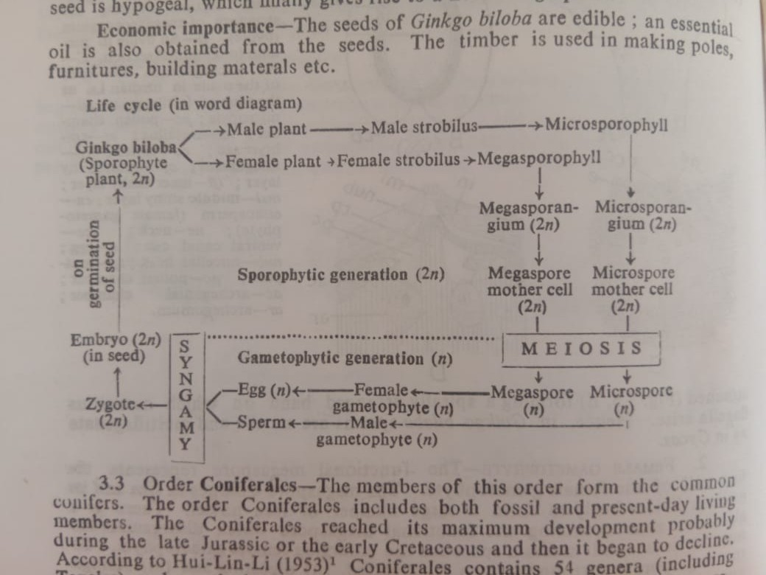
Economic importance
The seed of the Ginkgo biloba is edible; an essential oil is obtained from the seeds. The timber is used in making poles, furnitures, building materials etc.

