Growth hormones
Most of the physiological activities and growth in plants are regulated by the action and interaction of some chemical substances in them called as hormones and by naturally occurring inhibitors e.g. phenol, flavonols and abscisic acid. The plant hormones are termed as phytohormones. It can be defined as organic substance produced naturally in the higher plants, controlling growth or other physiological functions at a site remote from its place of production and active in minute amounts.
These phytohormones have also been termed as growth hormones, growth promoting substances, growth substances, growth factors, growth regulators etc. by various workers.
Growth regulating substances may also be classified into following categories
- Auxins, e.g. Indole acetic acid (IAA)
- Gibberellins e.g. Gibberellic acid (GA)
- Cytokinins e.g. Kinetin, Zeatin etc.
- Ethylene e.g. Ethylene
- Dormins e.g. Abscissic acid (ABA), Phaseic acid, Xanthoxin etc.
- Flowering hormones e.g. Florigen, anthisin, Vernalin.
- Miscellaneous natural substances e.g. Cyclitols, Vitamins, Phytochrome, Traumatic substances etc.
- Phenolic substances e.g. Coumarin
- Synthetic growth retardants e.g. CCC, AMO 1618, Phosphon D, Morphactins, Malformins, Maleic hydrazide (MH) etc.
- Miscellaneous Synthetic substances e.g. Synthetic Auxins, Synthetic Cytokinins.

Natural growth hormones in plants
The auxins were the first hormones to be discovered in plants and at one time considered to be the only naturally occurring plant growth hormones. Since then besides other less important hormones, two important groups of chemical substances having profound influence on the regulation of growth and development in plants, have been discovered that are considered as natural plant growth hormones. They are gibberllins and cytokinins. Beside these, ethylene and absicisic acid (ABA) and recently brassinosteroids have also acquired status of natural plant growth regulator.

Discovery of auxins
The discovery of auxins was proposed by Charles Darwin (1880) in his book the power of movements in plants. Darwin in his words said that when seedlings are freely exposed to lateral light some influence is transmitted from the upper to the lower part causing the later bend. He proved this by the following experiment; he exposed grass coleoptiles to unilateral light and observed it to bend towards the light. He covered the coleoptiles tip with tin foil or cut it off so that it was not acted upon by light and observed that coleoptiles did not bend towards the unilateral light. Thus he concluded from his experiment that some stimulus is transmitted from upper to the lower part which induced bending of the coleoptiles.
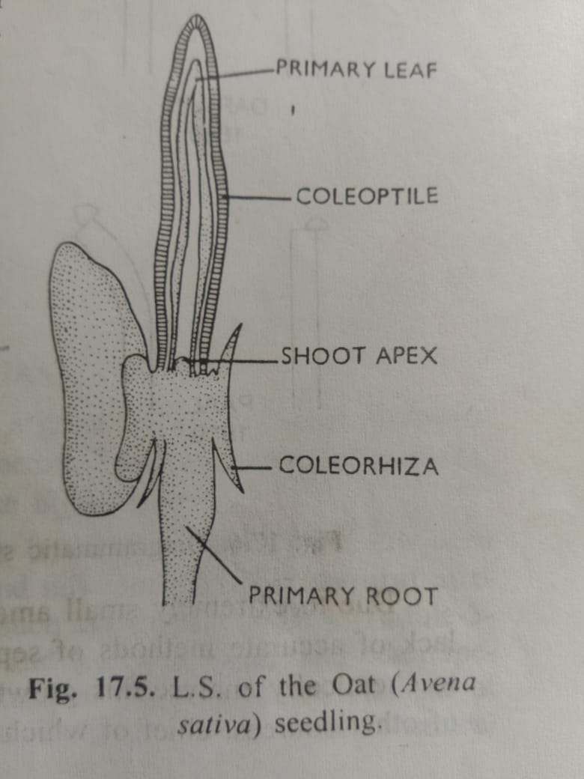
Similar kind of observations were made by Boysen-Jensen (1910) while working on oat coleoptiles. They wrote that the transmission of irrigation is of a material nature produced by concentration changes in the coleoptiles tip. He cut off the coleoptiles tip and replaced it with a thin plate of gelatine inserted between the tip and cut stump and observed that coleoptile could still bend towards unilateral light.
Paal (1919) endorsed his findings saying that the stem tip is the seat of growth regulating centre. In it a substance is formed and internally secreted, and this substance, equally distributed on all sides, moves downwards through a long time. He cut off the tip of the coleoptiles and replaced it asymmetrically on the cut coleoptiles stump and discovered that the coleoptiles bent away from the side bearing tip even in dark. Thus he concluded that the tip secretes a substance which promotes the growth of part below it. When the tip is intact and receiving uniform light all sides the growth is symmetrical. Therefore, the asymmetrical growth of the coleoptiles resulting in curvature towards unilateral light must have been due to an asymmetrical distribution of this growth substances. Larger amounts of this substance on the shaded side cause that side to grow more and the coleoptiles to bend towards unilateral light.
F.W.Went (1926, 1928) was successful in isolating this growth substance from Avena coleptile tips which still retained the growth promoting activity. He cut off the tips of the Avena coleptiles and placed them on small agar block for certain period of time and then placed agar blocks asymmetrically on cut coleoptiles stumps. All the coleoptiles showed typical curvature even in dark. He also developed a method for determining the amount of the growth substance (i.e. Auxin)which is active in very small amounts in the Avena coleptile tips. This method of bioassay is famous by the name of Avena curvature test.
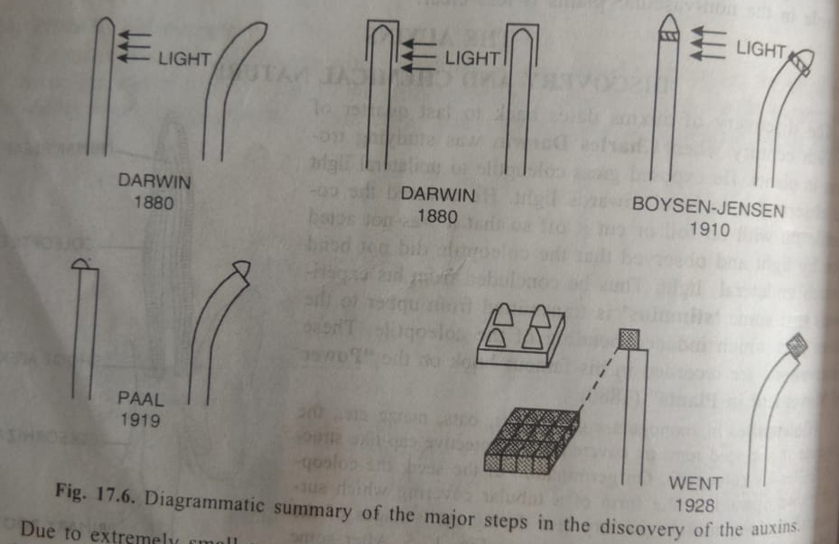
Characteristics of auxins
Auxins are characterized by the following features
- Polar translocation (from apex to downward movement)
- Apical bud dominance
- Variable behaviour of root and shoot growth
- Root initiation
- Delay in abscission
- Differentiation of xylem elements

Physiological roles of auxins
- Cell elongation
The primary physiological effect of auxin in plants is to stimulate the elongation of cells. A very common example of this can be observed in phototrophic curvatures where the unilateral light unequally distributes the auxin in the stem tip. The higher concentration of auxin on the shaded side causes the cells on that side to elongate more rapidly resulting in bending of the stem tip towards the unilateral light.
- Apical dominance
It has been common observation in many vascular plants especially the tall and sparsely branched ones that if the terminal bud is intact and growing, the growth of the lateral buds just below it remained suppressed. Removal of the apical bud results in the rapid growth of the lateral buds. This phenomenon in which the apical bud dominates over the lateral buds and does not allow the later to grow is called apical dominance.
- Root initiation
The higher concentration of auxin inhibits the elongation of root but the number of lateral branch roots is considerably increased i.e. the higher concentration of auxin initiates more lateral branch roots.
Application of IAA in lanolin paste to the cut end of a young stem results in an early and extensive rooting. This fact is of great practical importance and has been widely utilised to promote root formation in economically useful plants which are propagated by cuttings.
- Prevention of abscission
Natural auxins have controlling influence on the abscission of leaves, fruits etc.
- Parthenocarpy
Auxin can induce the formation of parthenocarpic fruits. In nature also, this phenomenon is not uncommon and in such cases the concentration of auxins in the ovaries has been found to be higher than the ovaries of plants which produce fruits after fertilization. In the later cases, the concentration of auxin in ovaries increases after pollination and fertilization.
- Respiration
It has been established that auxins stimulates respiration and there is a correlation between auxin induced growth and an increased respiration rate. According to French and Beevers (1953), the auxin may increase the rate of respiration indirectly through increased supply of ADP by rapidly utilizing ATP in the expanding cells.

- Callus formation
Besides cell elongation auxin may also be active in cell division. In fact in many tissue cultures where the callus growth is quite normal, the continued growth of such callus takes place only after the addition of auxin.
- Vascular differentiation
Auxin includes vascular differentiation in plants. This has also been confirmed in tissue culture experiments and from the studied with transgenic plants. Cytokinine are also known to participate in differentiation of vascular tissue and it is believed that differentiation in plants is probably under the control of both auxin and cytokinins

Biosynthesis of Auxin (IAA) in plants
- Tryptophan dependent pathways
In 1935, Thimann demonstrated that a fungus Rhizopus suinus could convert amino acid tryptophan (trp) into indole acetic acid (IAA). Since then, it is generally held that tryptophan is primary precursor of IAA in plants.
The IAA can be formed from tryptophan by 4 different pathways
- TAM (tryptamine ) pathway
Tryptophan is decarboxylated to form tryptamine (TAM) followed by deamination of the later resulting in the formation of indole-3-acetaldehyde (IAld). The enzymes involved in tryptophan decarboxylase and tryptamine oxidase respectively. IAld is readily oxidised to IAA by enzyme IAld dehydrogenase.
- IPA (Indole -3-pyruvic acid) pathway
Tryptophan is deaminated to IPA followed by decarboxylation of the later resulting in the formation of IAld. The enzymes involved are tryptophan transaminase and indole pyruvate decarboxylase.
One of the above 2 methods is most common pathway of IAA formation in plants
- IAN (Indole -3-acetonitrile) pathway
It occurs in some especially those belonging to families Brassicaceae, Poaceae and Musaceae.
Tryptophan is converted into IAA in the presence of enzyme nitrilase. Indole-3-acetaldoxime and indole-3-acetonitrile (IAN) are the intermediates
- Bacterial pathway
In some pathogenic bacteria such as Agrobacterium tumefaciens and Pseudomonas savastanoi, tryptophan is first converted into indole-3-acetamide (IAM) in the presence of tryptophan monooxygenase. IAM is then hydrolysed to IAA in the presence of the enzyme IAM hydrolase. The auxin (IAA) produced in this way often causes morphological changes in the host plants.
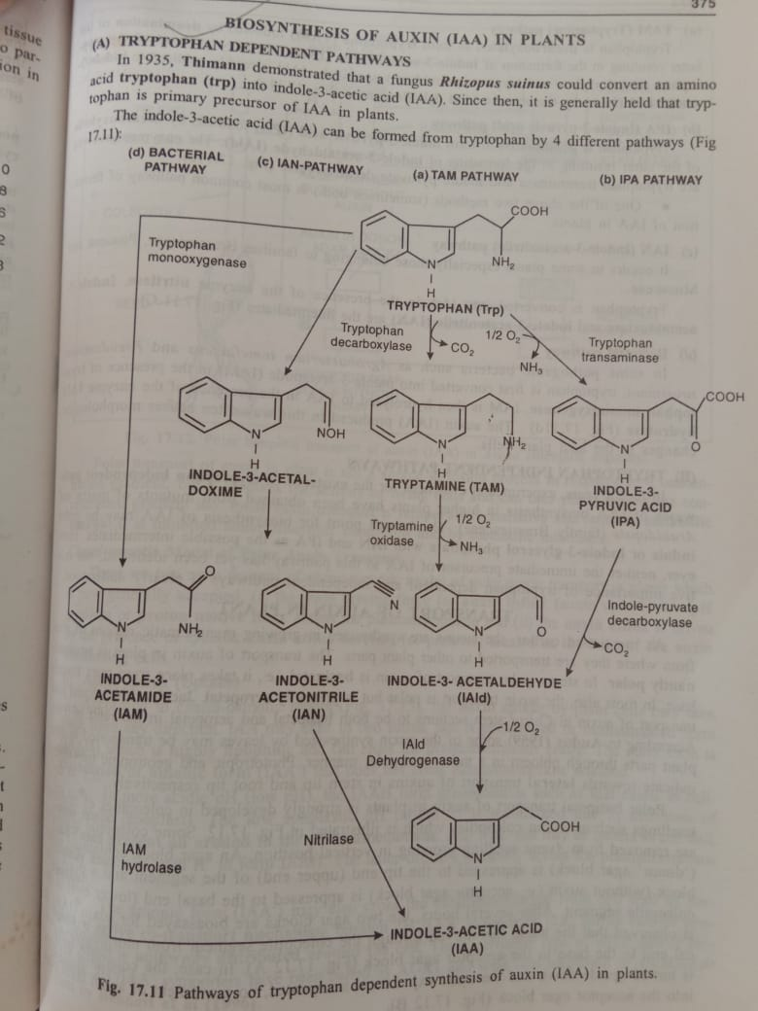
- Tryptophan independent pathways
In recent years, experimental evidences for the existence of tryptophan independent pathways of IAA biosynthesis in higher plants have been obtained from mutant of maize and Arabidopsis (family Brassicaceae). The branch point for biosynthesis of IAA may be either indole or indole-3-glycerol phosphate with IAN and IPA as the possible intermediates. However, neither the intermediate precursor of IAA in this pathway has yet been identified, nor relative importance of tryptophan dependent and independent pathways is clearly understood.

