Rreproduction of Pinus
Vegetative reproduction has not been reported. The Pinus plant represents the sporophytic generation. The plant is monoecius i.e. male and female sporophylls are borne on the same plant but in separate cones i.e. strobili. Flowers are unisexual, they are represented by sporophylls i.e. male flowers by microsporophylls (stamens) and female flowers by megasporophylls (carpels).
Male cone i.e. Staminate strobilus
Male cones are simple, they form compact and oval structures, measuring about 2-3 cm in length. They occur singly in the axils of scale leaves of long shoots replacing thereby dwarf shoots. Male cone thus appear to be morphologically equivalent to dwarf shoots.
Each cone is provide with a short and elongated central axis upon which numerous microsporophylls are arranged spirally. The microsporophylls are borne directly on the central axis, therefore the male cone is homologous to male flower of an angiosperm and not an inflorescence. Microsporophylls are scaly and they vary from 60 -135 in number in each cone. Each microsporophyll consists of a short stalk (i.e. filament) and leaf-like expanded structure, the apex of which is slightly bent upwards. Two microsporangia are borne on the lower i.e. abaxial surface of such leaf-like expanded portion of each microsporophyll.
A microsporangium is sessile and oblong in shape, it consists of a wall of several layers of cells. The development of the microsporangium is of eusporangiate type. A nearly mature microsporangium contains inside microspore mother cells surrounded externally by a sporangium wall and tapetum. Each microspore mother cell by reduction division forms four haploid, uninucleate microspore i.e. pollen grains. Each mature microsporangium, therefore, contains numerous microspores. The pollen grains are winged and yellow in colour. When mature each microsporangium dehisces by a longitudinal slit along the long axis. As a result large number of pollen grains get released forming a cloud which is often called shower of sulphur.
Female cone i.e. ovulate strobilus
Female cones form true cone-like structures and they are compound in nature. They arise in cluster of 1-4 in the axils ao scale leaves of the long shoots taking the position of dwarf shoots. At first they are green in colour and gradually become brown-red.
The female cone is hard, woody and dry structure, it consists of central axis upon which numerous megasporophylls are spirally arranged.
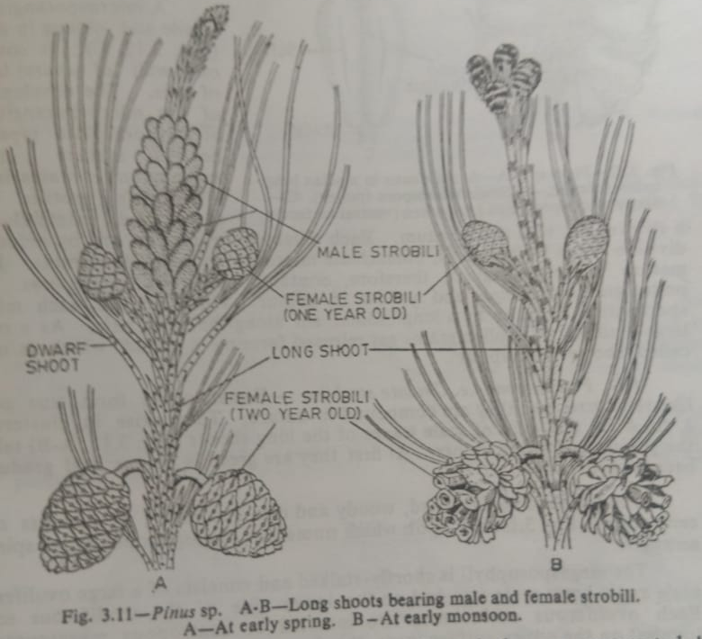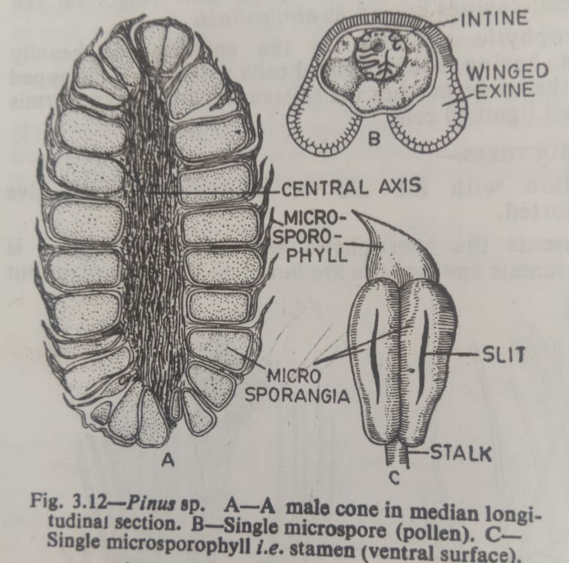
The megasporophyll is shortly stalked and consists of large ovuliferous scale and bract scale attached on the lower side of the ovuliferous scale. Each ovuliferous scale bears two inverted or anatropous meagsporangia (ovules) on the upper surface near the base. Bract scale and ovuliferous scale are supplied with separate vascular traces.
An ovule consists of a massive nucellus surrounded by an integument. The integument is fused with the nucellus at the basal region and open at the top to form an micropyl. Nucellar beak and pollen chamber are not formed here. The integument consists of three fused layers e.g. an outer flesy, a middle stony and an inner fleshy.
Only megaspore mother cell is differentiated within the nucellar tissue, which by meiosis gives rise to a linear-tetrad of four megaspores. Of these four megaspore, only the lowermost one is the functional megaspore while others degenerate.
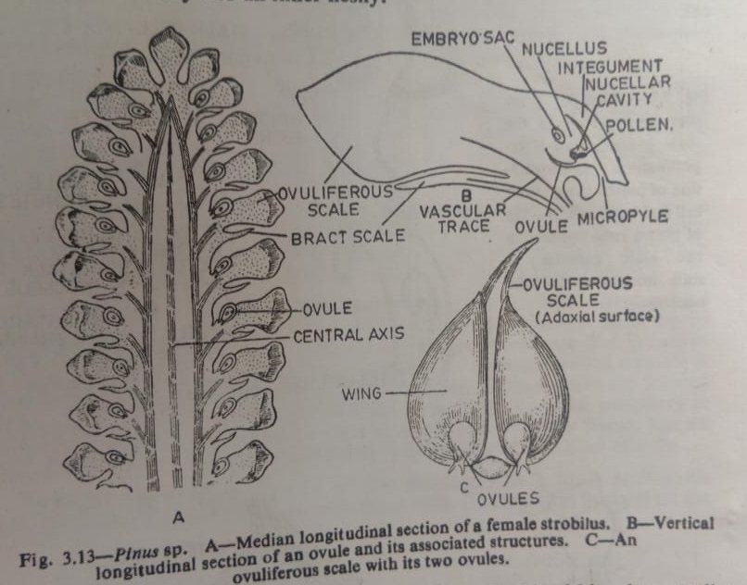
Pollination
Pollen grains, after liberation from microsporangia, are carried by means of wind at 4-celled stage. The yellow colours pollen grains are carried in a mass and they resemble dust of sulphur.
At the time of pollination, the scales of the female cone remain open for the reception of pollen grains, and pollen are caught in the mucilage drop oozing out of the micropyle. As the mucilage drop dries up, pollen grains are gradually drawn down the micropyle and finally taken at the nucellus tip.
Fertilization
Fertilization takes place after an year of pollination. Pollen tube makes its way down until it reaches the neck of the archegonium, the neck is penetrated and the tip of the pollen tube bursts. The contents of pollen tube are then discharged and of the two male cells, only one unites with the egg i.e. oosphere, as a result a diploid zygote i.e. oospore is formed.
Endosperm is cellular and is formed before fertilization from the megaspore nucleus due to repeated divisions. Endosperm tissue is therefore haploid (n).
Embryo and seed
First division of the zygote nucleus is not accompanied by a vertical wall, instead free nuclear division takes place. Polyembryony occurs as four potential embryos are developed although only one of them matures. Mature embryo in seed consists of a radical, the hypocotyls, 3 to many cotyledons and plemule.
Seeds winged, without aril, testa hard and brown. After a period of rest the seed germinates by epigeal means to form a new sporophytic palnt.
Life cycle
Economic importance of Pinus
Most of the species of Pinus have economic value. The seeds of P. gerardiana are edible and commonly known as ‘chilgoza’. P. roxburghii and P. wallichiana are timber yielding plants; the timber is used for making furnitures, poles, match boxes, building materials etc. some species e.g. P. roxburghii and P. insularus are important sources of resin and turpentine.
Morphology of the Ovuliferous scale of Pinus
Various morphological interpretations have been offered by different authors regarding the morphological nature of the ovuliferous scale of Pinus. Some of the interpretations given by different author are
- Robert Brown (1827)- It is an exposed carpel developing in the axil of the bract and which bears two naked ovules.
- Schleiden (1829)- interpreted the ovuliferous scale as an axil placenta which arises in the axil of the leafbearing two ovules. The scale is the true carpel
- A. Brown (1842)- it represents the first two leaves of an axillary shoot which are fused by their posterior margins.
- Baillon (1863)- it is regarded as an axillary shoot bearing two bicarpellary ovaries.
- Eicher (1868)- bract is a carpel and the ovuliferous scale is a ligular outgrowth from the upper surface.
- Sachs (1868)- regarded bract scale as a carpel and the ovuliferous scale as a ligular outgrowth on its surface.
- Van Tiegham (1869)- the ovuliferous scale is the first and only leaf of an axillary shoot.
- Von Mohl(1871)- the ovuliferous scale represents the first two leaves of an axillary shoot.
- Stanzel (1876)- the ovuliferous scale is made up of the first two leaves of an axillary shoot.
- Chelakovsky(1879)- ovuliferous scale is the representation of the axillary shoot.
- Master ( 1892)- ovuliferous scale is an outgrowth, either from the bract or from the axis, in the nature of a cladode of the modified shoot.
- Bessey(1892)- regarded the ovuliferous scale as a chalazal development of the ovules.
- Chamberlain(1935)- the ovuliferous scale is modified shoot with or without leaves bearing the ovules.
- Florin(1951)- the ovuliferous scale is not a sporophyll, it is a highly modified lateral dwarf shoot or flower.

