Unit 8: Plant growth regulators LL (6 lectures)
Discovery and physiological roles of auxins, gibberellins, cytokinins, ABA, ethylene.

Growth
Growth can be defined as a “vital process which brings about a permanent change in any plant or its part in respect to its size, form, weight and volume.”
Growth in a plant is the outcome of cell division, enlargement of new cells and their differentiation into different types of tissues. These processes of growth are accompanied by
- A permanent change in size (usually an increase in length or volume) and
- An increase in the dry weight of growing parts.
Growth regions
Typical growth regions in plants are the apices of shoots and roots. Such growing regions are known as apical meristems, primary meristems, or regions of primary growth. These apical meristems are responsible for the increase in length, differentiation of various appendages and formation of plant tissues. In some cases, for example, bamboo and mint however, the increase in length also occurs due to intercalary meristams. These intercalary meristems are considered as portions of apical meristems separated by permanent tissues and are temporary regions of growth. The third kind of growing region is the region of lateral meristems which brings about secondary growth to increase the thicknesss of plant in girth (secondary growth).
Phases of growth
Growth is not a simple process. It occurs in meristematic regions where before the completion of this process, a meristematic cell has to pass through the following three phases.
- Cell formation phase
- Cell elongation phase
- Cell differentiation (cell maturation) phase
These phases can be seen clearly in a longitudinal section of root apex where the cell formation phase is represented by meristematic zone and the cell enlargement phase by cell elongation zone.
The dividing meristematic cells are thin walled and isodiametric and have a dense protoplasm with a large nucleus and without or with very small vacuoles. The intercellular spaces are also absent. The newly formed cells after the first phase of cell division have to pass through the second phase of cell enlargement. During the phase of cell elongation on account of presence of large quantities of solutes inside the growing cells, water enters the cell due to osmotic effect resulting in increased turgidity and expansion and dilation of the thin and elastic cell wall. During elongation of cell wall, cellulose molecules are deposited either by intussusceptions or apposition. Some people also think that the increase in volume of the cell occurs first due to deposition of cellulose molecules due to which more water is absorbed and turgidity increases. This phase also results in the appearance of large vacuoles. In the last phase or cell maturation secondary walls are laid down and the cell matures and gets differentiated into permanent tissue.

Growth curve/ the course of growth/ Grand period of growth/ Sigmoid curve/ Grand period curve
Whether the growth rate of a cell, a plant organ, a whole plant or the whole life cycle of plant measured in terms of length, size, area volume or weight. Usually under favourable conditions there is a characteristics course of increase in plants in any of its growing parts. The growth has been found that different growth phases result in a S-shaped curve (or sigmoid curve). In a standard growth curve there are few well-marked regions obtained. Growth is slow at first (Lag phase), then growing speeds (Log phase) and eventually slows down (Decreasing Growth phase/linear phase) to come to halt (steady state/senescence phase). The total time during which this course of growth takes place is called as the Grand Period of Growth. If this growth rate is plotted against time, a S-shaped curve is obtained which is called as Sigmoid Curve or grand Period Curve.
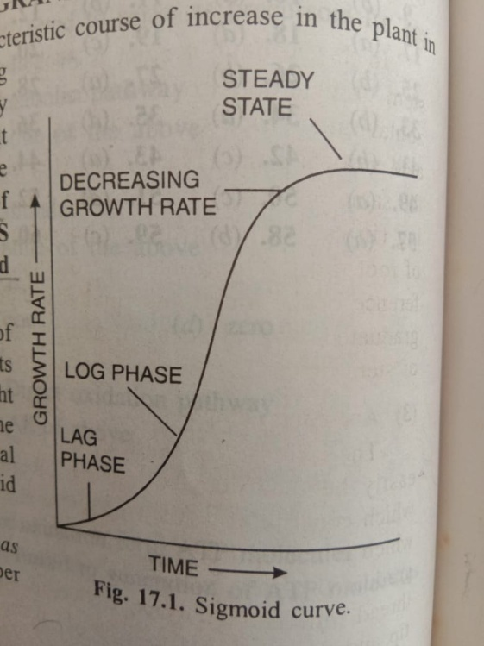
Standard growth is S-shaped or sigmoidal comprising four phases, initial lag phase during which cells active their biochemical machinery for rapid growth by synthesizing necessary enzymes. This is followed by a time period during which there is exponential increase in cell number which is called log phase. This period of rapid growth does not continue indefinitely and due to depleted nutrient supply, accumulation of toxic products and other limiting factors ultimately leads to decreasing cell until the population of cells reaches a steady state in which the number of cells remains constant (stationary) or even declines.
This growth curve suits well to the entire life of an annual plant when measured in terms of dry weight against time. Some exceptions are also seen. In senescent plant, there is a fall in the growth rate because of increased catabolic processes while in case of early stage of seed germination and sprouting tubers, decrease in dry weight is due to utilization of stored food. Environmental conditions may alter growth rates but not the sigmoid form of the growth curve.
Kinetics of growth
Growth can be measured from two view points, i.e. Absolute Growth rate (AGR) or Relative Growth Rate (RGR). AGR is the total growth per unit time and determined when the field of a plant or organ is to be calculated. RGR is the growth of each per unit time expressed per unit of the critical weight or volume. RGR is measured when growth rate of two plants are compared.
Mathematically AGR and RGR expressed as follows
The ratio of change in cell weight (dw) over the time interval (dt) is called as AGR= dw/dt
The AGR when divided by total weight gives RGR, RGR= AGR/w

