Introduction
Have you been through airport security lately? If you have, you’ve probably noticed that it’s carefully designed to let some things in (such as passengers with tickets) and to keep others out (such as weapons, explosives, and bottled water). Flight attendants, captains, and airport personnel travel through quickly via a special channel, while regular passengers pass through more slowly, sometimes with a long wait in line.
In many ways, airport security is a lot like the plasma membrane of a cell. Cell membranes are selectively permeable, regulating which substances can pass through, as well as how much of each substance can enter or exit at a given time. Selective permeability is essential to cells’ ability to obtain nutrients, eliminate wastes, and maintain a stable interior environment different than that of the surroundings (maintain homeostasis).
The simplest forms of transport across a membrane are passive. Passive transport does not require the cell to expend any energy and involves a substance diffusing down its concentration gradient across a membrane. A concentration gradient is a just a region of space over which the concentration of a substance changes, and substances will naturally move down their gradients, from an area of higher to an area of lower concentration.
In cells, some molecules can move down their concentration gradients by crossing the lipid portion of the membrane directly, while others must pass through membrane proteins in a process called facilitated diffusion. Here, we’ll look in more detail at membrane permeability and different modes of passive transport.
Selective permeability
The phospholipids of plasma membranes are amphipathic: they have both hydrophilic (water-loving) and hydrophobic (water-fearing) regions. The hydrophobic core of the plasma membrane helps some materials move through the membrane, while it blocks the movement of others.
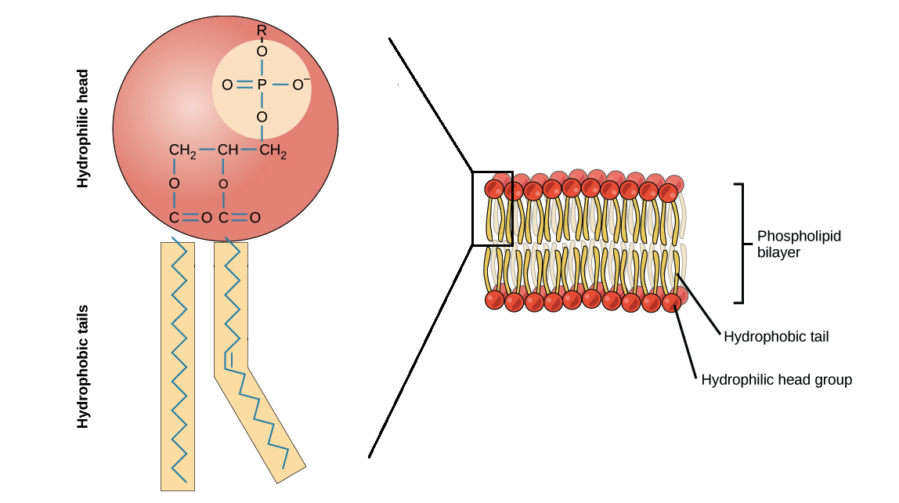
Polar and charged molecules have much more trouble crossing the membrane. Polar molecules can easily interact with the outer face of the membrane, where the negatively charged head groups are found, but they have difficulty passing through its hydrophobic core. Water molecules, for instance, cannot cross the membrane rapidly (although thanks to their small size and lack of a full charge, they can cross at a slow rate).
Additionally, while small ions are the right size to slip through the membrane, their charge prevents them from doing so. This means that ions like sodium, potassium, calcium, and chloride cannot cross membranes to any significant degree by simple diffusion and must instead be transported by specialized proteins (which we’ll discuss later). Larger charged and polar molecules, like sugars and amino acids, also need help from proteins to efficiently cross the membrane.
Diffusion
In the process of diffusion, a substance tends to move from an area of high concentration to an area of low concentration until its concentration becomes equal throughout a space. For example, think about someone opening a bottle of cleaning ammonia in the middle of a room. The ammonia molecules will initially be most concentrated right where the person opened the bottle, with few or no molecules at the edges of the room. Gradually, the ammonia molecules will diffuse, or spread, away from the place where they were released, and eventually you’ll be able to smell ammonia at the edges of the room. Ultimately, if the bottle is capped and the room is closed, the ammonia molecules will become evenly distributed throughout its volume.
The same will happen with molecules of any type: as a population, they tend to move from an area where they’re more concentrated to an area where they’re less concentrated. To understand this, imagine that there’s an area where molecules are more concentrated (such as where ammonia has just been opened) and an area where they’re less concentrated (the surrounding room). Since there are lots of ammonia molecules in the concentrated area, it’s likely that one will move from there into the non-concentrated area. But since there are few molecules of ammonia in the non-concentrated area, it’s unlikely that the reverse will happen.
Thus, over time, the net movement of molecules will be out of the more concentrated area and into the less concentrated one, until the concentrations become equal (at which point, it’s equally likely for a molecule to move in either direction). This process does not require any energy input; in fact, a concentration gradient itself is a form of stored (potential) energy, and this energy is used up as the concentrations equalize.
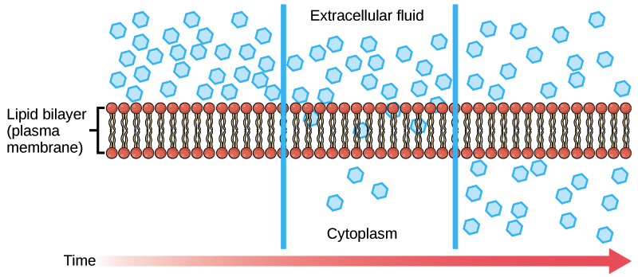

Molecules can move through the cell’s cytosol by diffusion, and some molecules also diffuse across the plasma membrane (as shown in the picture above). Each individual substance in a solution or space has its own concentration gradient, independent of the concentration gradients of other materials, and will diffuse according to that gradient. Other factors being equal, a stronger concentration gradient (larger concentration difference between regions) results in faster diffusion. Thus, in a single cell, there can be different rates and directions of diffusion for different molecules. For example, oxygen might move into the cell by diffusion, while at the same time, carbon dioxide might move out in obedience to its own concentration gradient.
Facilitated diffusion
Some molecules, such as carbon dioxide and oxygen, can diffuse across the plasma membrane directly, but others need help to cross its hydrophobic core. In facilitated diffusion, molecules diffuse across the plasma membrane with assistance from membrane proteins, such as channels and carriers.
A concentration gradient exists for these molecules, so they have the potential to diffuse into (or out of) the cell by moving down it. However, because they are charged or polar, they can't cross the phospholipid part of the membrane without help. Facilitated transport proteins shield these molecules from the hydrophobic core of the membrane, providing a route by which they can cross. Two major classes of facilitated transport proteins are channels and carrier proteins.
Channels
Channel proteins span the membrane and make hydrophilic tunnels across it, allowing their target molecules to pass through by diffusion. Channels are very selective and will accept only one type of molecule (or a few closely related molecules) for transport. Passage through a channel protein allows polar and charged compounds to avoid the hydrophobic core of the plasma membrane, which would otherwise slow or block their entry into the cell.
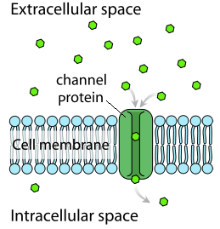

Aquaporins are channel proteins that allow water to cross the membrane very quickly, and they play important roles in plant cells, red blood cells, and certain parts of the kidney (where they minimize the amount of water lost as urine).
Some channel proteins are open all the time, but others are “gated,” meaning that the channel can open or close in response to a signal (like an electrical signal or the binding of a molecule). Cells involved in the transmission of electrical signals, such as nerve and muscle cells, have gated ion channels for sodium, potassium, and calcium ions in their membranes. The opening and closing of these channels, and the resulting shifts in ion levels inside the cell, play an important role in electrical transmission along membranes (in nerve cells) and in muscle contraction (in muscle cells).
Carrier proteins
Another class of transmembrane proteins involved in facilitated transport consists of the carrier proteins. Carrier proteins can change their shape to move a target molecule from one side of the membrane to the other.
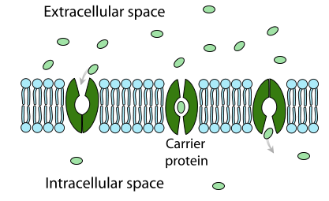
Like channel proteins, carrier proteins are typically selective for one or a few substances. Often, they will change shape in response to binding of their target molecule, with the shape change moving the molecule to the opposite side of the membrane. The carrier proteins involved in facilitated diffusion simply provide hydrophilic molecules with a way to move down an existing concentration gradient (rather than acting as pumps).
Channel and carrier proteins transport material at different rates. In general, channel proteins transport molecules much more quickly than do carrier proteins. This is because channel proteins are simple tunnels; unlike carrier proteins, they don’t need to change shape and “reset” each time they move a molecule. A typical channel protein might facilitate diffusion at a rate of tens of millions of molecules per second, whereas a carrier protein might work at a rate of a thousand or so molecules per second

