Active and passive transport are two methods that transport molecules across the cell membrane. A cell membrane is a multi-task unit which gives structure to the cell while protecting the cytosolic content from the extracellular environment. The movement of molecules in and out of the cell is determined by the phospholipid bilayer, maintaining a delicate homeostasis of the cell. The phospholipid bilayer is semi-permeable, allowing some molecules to freely pass the membrane through a concentration gradient and some molecules to use special structures in order to pass the membrane and others to pass the membrane by utilizing cellular energy. The main difference between active and passive transport is that active transport pumps molecules against the concentration gradient using ATP energy whereas passive transport allows the molecules to pass the membrane through a concentration gradient, requiring no cellular energy.
What is Active Transport
Active transport is the movement of molecules across the membrane against the concentration gradient with the assistance of enzymes and usage of cellular energy. It is required for the accumulation of molecules like glucose, amino acids, and ions inside the cell in high concentrations. Two types of active transport can be identified: primary active transport and secondary active transport.

Primary Active Transport
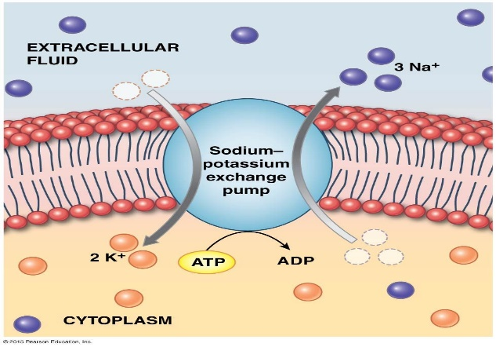
During primary active transport, the presence of substances in the extracellular fluid that is required by the cell is recognized by the specialized trans-membrane proteins on the cell membrane, which serve as pumps of transporting molecules. These trans-membrane proteins are powered by ATP. The primary active transport is most obvious in the sodium/potassium pump (Na+/K+ ATPase), which maintains the resting potential of the cell. The energy released by the hydrolysis of ATP is used to pump three sodium ions out of the cell and two potassium ions into the cell. Here, sodium ions are transported from a lower concentration of 10 mM to a higher concentration of 145 mM. Potassium ions are transported from a 140 mM concentration inside the cell to a 5 mM concentration of extracellular fluid. The proton/potassium pump (H+/K+ ATPase) is found in the lining of the stomach, maintaining an acidic environment inside the stomach. Omeprazole is a proton/potassium pump inhibitor, reducing the acid reflux inside the stomach. During both oxidative phosphorylation and photophosphorylation of electron transport chain use primary active transport to create a reducing power as well.
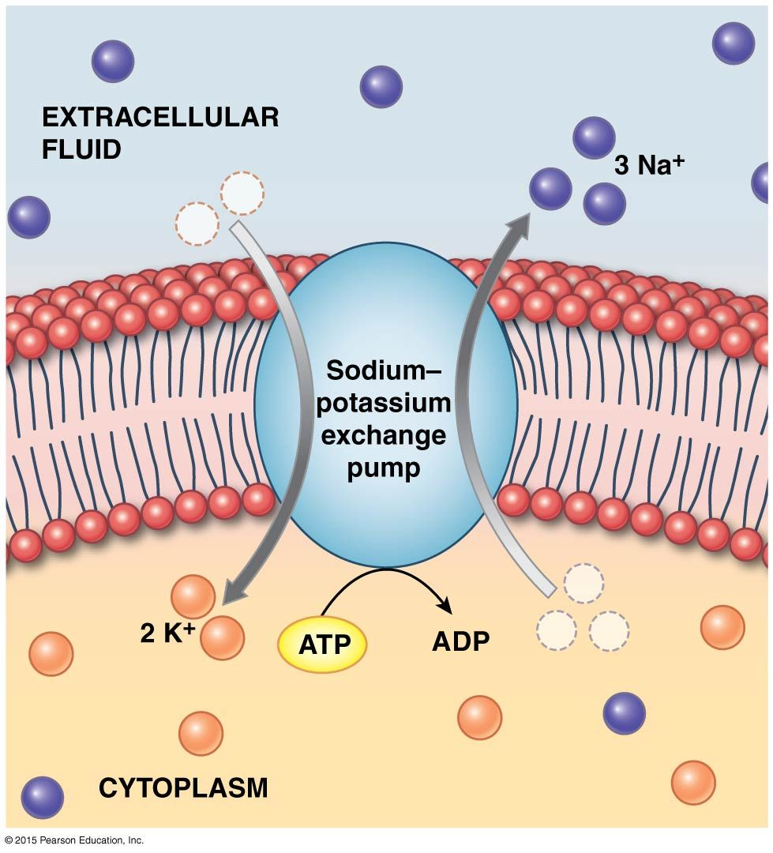

Secondary Active Transport
Secondary active transport is powered by an electrochemical gradient. Here, channels are made by pore-forming proteins. A simultaneous movement of another substance against the concentration gradient is observed with the secondary active transport. Hence, the channel proteins involved in the secondary active transport can be identified as cotransporters. There are two types of cotransporters: antiporters and symporters. Ion and the solute are transported in the opposite directions by antiporters. Sodium/calcium exchanger, which allows the restoration of calcium ion concentration in the cardiomyocyte after the action potential, is the most common example for antiporters. Ions are transported through the concentration gradient while the solute is transported against the concentration gradient by symporters. Here, both molecules are transported in the same direction across the cell membrane. SGLT2 is a symporter that transports glucose into the cell along with the sodium ions.

What is Passive Transport
Passive transport is the movement of molecules across the membrane through a concentration gradient with no use of cellular energy by the movement. It uses natural entropy to move molecules from a higher concentration to a lower concentration until the concentration becomes equalized. Then, there will be no net movement of molecules at the equilibrium. Four main types of passive transport are found: osmosis, simple diffusion, facilitated diffusion, and filtration. The simple movement of molecules across a permeable membrane is called simple diffusion. Small, non-polar molecules use simple diffusion. The diffusion distance should be less in order to maintain a better flow.

During facilitated diffusion, special transport proteins are used to guide the movement of polar molecules and large ions. These transport proteins are glycoproteins and are specific to a particular protein. The GLUT4 is a glucose transporter that transports glucose from the bloodstream into the cell. It is mostly found in fat and skeletal muscles. Three types of transport proteins are involved in the facilitated diffusion: channel proteins, aquaporins, and carrier proteins. Channel proteins make hydrophobic tunnels across the membrane, allowing the selected hydrophobic molecules to pass through the membrane. Some channel proteins are opened at all times, and some are gated like ion channel proteins. Aquaporins allow water to cross the membrane quickly. Carrier proteins change their shape, transporting target molecules across the membrane.

