Allied Fungi
What is allied fungi: Two fungi sharing space and colonizing together in mutualism, one gives more shade and humidity to the community, the other surely is a more capable saprophytic and predigests more easily the substrate they are sharing.
General characteristic of allied fungi:
1. Fungi are cosmopolitan in distribution i.e., they can grow in any place where life is possible.
2. They are heterotrophic in nature due to the absence of chlorophyll. On the basis of their mode of nutrition, they may be parasite, saprophyte or symbionts.
3. The plant body may be unicellular (Synchytrium, Saccharomyces) or filamentous (Mucor, Aspergillus). The filament is known as hypha (plural, hyphae) and its entangled mass is known as mycelium.
4. The hypha may be aseptate i.e., coenocytic (without septa and containing many nuclei) or septate. The septate mycelium in its cell may contain only one (monokaryotic), two (dikaryotic) or more nuclei.
5. The septa between the cell may have different types of pores: micropore (Geotri- chum), simple pore (most of the Ascomycotina and Deuteromycotina) or dolipore (Basidiomycotina, except rusts and smuts).
6. The cells are surrounded by distinct cell wall (except slime molds), composed of fungal cellulose i.e., chitin; but in some lower fungi (members of Oomycetes), the cell wall is composed of cellulose or glucan.
7. The cells generally contain colourless protoplasm due to absence of chlorophyll, containing nucleus, mitochondria, endoplasmic reticulum, ribosomes, vesicle, microbodies, etc.
8. The cells are haploid, dikaryotic or diploid. The diploid phase is ephemeral (short-lived).
9. In lower fungi like Mastigomycotina, the reproductive cells (zoospores and gametes) may be uni- or biflagellate, having whiplash and/or tinsel type of flagella. But in higher fungi like Zygomycotina, Ascomycotina, Basidiomycotina and Deuteromycotina, motile cells never form at any stage.
10. In response to functional need, the fungal mycelia are modified into different types such as: Plectenchyma, Stroma, Rhizo- morph, Sclerotium, Hyphal trap, Appreso- rium, Haustorium, etc.

11. The unicellular fungi, where entire plant body becomes converted into reproductive unit, are known as holocarpic fungi (e.g., Synchytrium). However, in many others, only a part of the mycelial plant body is converted into reproductive unit, thus they are called eucarpic fungi (e.g., Pythium, Phytophthora).
12. They reproduce by three means: Vegetative, asexual and sexual.
(a) Vegetative reproduction takes place by fragmentation (Mucor, Penicillium, Fusarium), budding (Saccharomyces, Ustilago) and fission (Saccharomyces).
(b) Asexual reproduction takes place by different types of spores. These are zoospores (Synchytrium), conidia (Pythium, Aspergillus), oidia (Rhizo- pus), chlamydospore (Fusarium), etc. The spores may be unicellular (Aspergillus) or multicellular (Alternaria)

Classification of Fungi

MYXOMYCOTINA (MYXOMYCETES or SLIME MOLD) 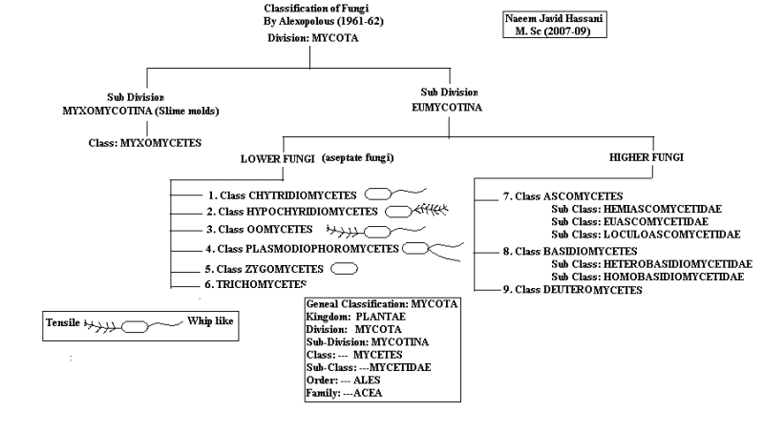

Classification of Division Myxomycota (Myxomycotina):
The classification of Myxomycota by Ainsworth (1973) is:
A. Class: Acrasiomycetes:
Acrasiomycetes are commonly known as cellular or amoeboid slime molds, and are found profusely in the upper layer of humus in deciduous forests and also in cultivated lands.
The characteristic features are:
1. Somatic phase commonly consists of amoeboid cells or myxamoebae.
2. Myxamoebae aggregate to form a pseudoplasmodium, which develops fruit body.
3. Lack of flagellated cells, except in Pocheina rosea.
4. Spore wall contains cellulose.
5. Fruit bodies may be sorocarps (in Dictyostelium) or sporocarp (in Protostelium).
B. Class: Hydromyxomycetes:
This group shows uncertain affinities. The thallus forms net plasmodium or filoplasmodium. They are commonly aquatic and saprobic, but rarely parasitic.
The characteristic features are:
1. The thallus consists of uninucleate spindle shaped cells, forming extensive filaments.
2. The filaments are tubular and form net-like structure, the net-plasmodium or filoplas- modium.
3. Reproduction by cyst formation, zoospore formation or by congregation.
The class consists of two orders Hydro- myxales and Labyrinthulales. But Hawksworth et al. (1983) excluded Hydromyxales from fungi and included it in Protozoans. The members of Labyrinthulales are parasitic on higher plants and also on marine algae. Labyrinthula macrocystis is a very common species, found as parasite on Zostera marina, the eel-grass.
C. Class: Myxomycetes:
This group is commonly known as true slime molds or plasmodial slime molds. They are commonly found in damp places, especially on old wood and other decomposing plant parts.
The characteristic features are:
1. The vegetative body is a free-living plasmodium.
2. They feed on yeast cells, protozoa, fungal spores and other substances.
3. Reproduction takes place by asexual and sexual means.
(a) Asexual reproduction takes place by fragmentation of plasmodium or binary fission in myxamoebae.
(b) Sexual reproduction takes place by fusion between flagellated zoospores or myxamoeba to form zygote, from which multinucleate plasmodium develops by mitotic divisions. They develop different types of fructification. These are sporangium, aethalium and plasmodiocarp. Meiosis takes place during spore formation in the fructification.

SALIENT FEATURE OF MYXOMYCETES (SLIME MOLD):
- The vegetative structure of the thallus is multicellular mass of protoplasm lacking a cell wall known as plasmodium or an aggregate of separate amoeboid cells known as plasmodium. The nuclei are dipoid.
- Myxomycetes are devoid of chlorophyll as such they exhibit saprophytic mode of nutrition. They feed on bacteria, yeast cells, fungal spores, protozoa and even on bits of organic matter.
- The plasmodium exhibits creeping movement by the help of ever changing plasmodial protoplast.
- Asexual reproduction takes place by producing fruit body. Fruit body are stalked or sessile, variously coloured. They release uninucleate haploid spores which may germinate producing uniflagellate or unequally biflagellate zoospores. After swimming for a period, the zoospors withdraw their flagella and the cells assume an amoeboid structure.
- In some species, spores germinate by forming amoeboid cells called myxamoeba.
- Sexual reproduction takes place by the fusion between myxamoeba or between the flagellated zoospores. The fusion cell or zygote undegoes successive nuclear division to form multinucleate plasmodium.
- The entire plasmodium of the Myxomycetes, while passing from the somatic to the reproductive phase, is usually converted into one or more fruiting bodies containing spores.
- The nuclear division preceding spore formation is meiotic as a result uninucleate haploid spores are formed. The spores have a cell wall of cellulose.
- Vegetative reproduction takes place either by fragmentation of a plasmodium or by formation of sclerotia (a waxy harden substance developing from plasmodium during drought)

TYPES OF PLASMODIA
Plasmodium, in fungi, a mobile multinucleate mass of cytoplasm without a firm cell wall. A plasmodium is characteristic of the vegetative phase of true slime molds (Myxomycetes) and such allied genera as Plasmodiophora and Spongospora.
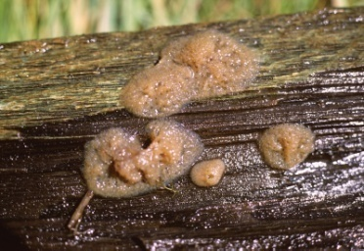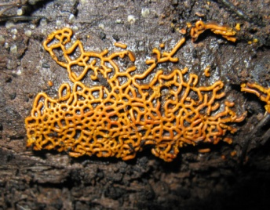
Fig. Types of plasmodia
TYPES OF PLASMODIA
There are three distinct plasmodial types generally recognized (Gray and Alexopoulos,¬ 1968; Keller and Braun, 1999):
- The protoplasmodium, characteristic of the Echinosteliales,
- The aphanoplasmodium, characteristic of the Stemonitales,
- The phaneroplasmodium, characteristic of the Physarales.
A fourth type intermediate between the aphano and phaneroplasmodium is termed as the trichiaceous plasmodium (Keller, 1971), and is characteristic of the Trichiales.
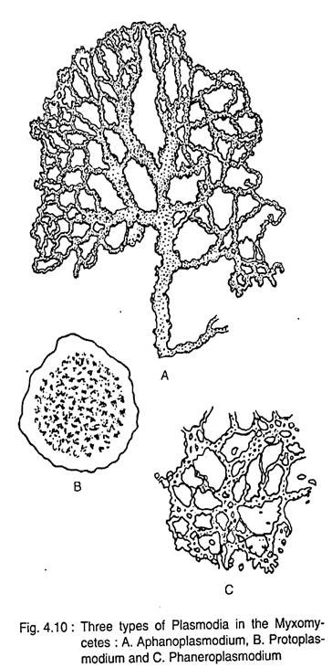

All of these plasmodial types are capable of movement as they feed, migrating different distances, and producing different types and numbers of fruiting bodies under optimal environmental conditions.

- Protoplasmodium

The protoplasmodium (Order Echinosteliales) remains microscopic throughout its development and migrates for short distances, usually less than 1mm. It has a plate-like shape that fails to develop advancing fans and trailing vein-like reticulate strands seen in other plasmodial types. Each tiny protoplasmodium gives rise to a single, tiny sporangium (usually less than 1mm), often occurring on the bark surface of living trees and vines. Species of Echinostelium and Clastoderma develop this type of plasmodium (Keller and Braun, 1999).

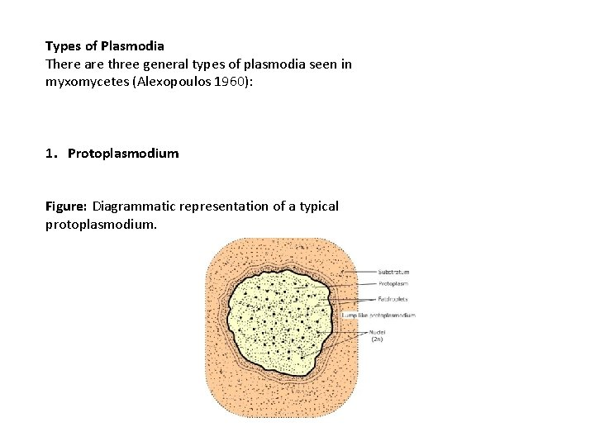

- Phaneroplasmodium
The phaneroplasmodium (Order Physarales) is the largest and often most colorful′ and frequently seen plasmodial type in the field. Polarity and directional movement at maturity result in an advancing, fan-shaped, anterior, feeding edge and a network of posterior trailing veins. Protoplasmic flow moves toward the anterior end of the plasmodium, slows, then stops, then reverses direction, flowing toward the posterior end. The entire plasmodium has a raised, three dimensional appearance with definite margins capable of covering and migrating up to 8m to drier sites.

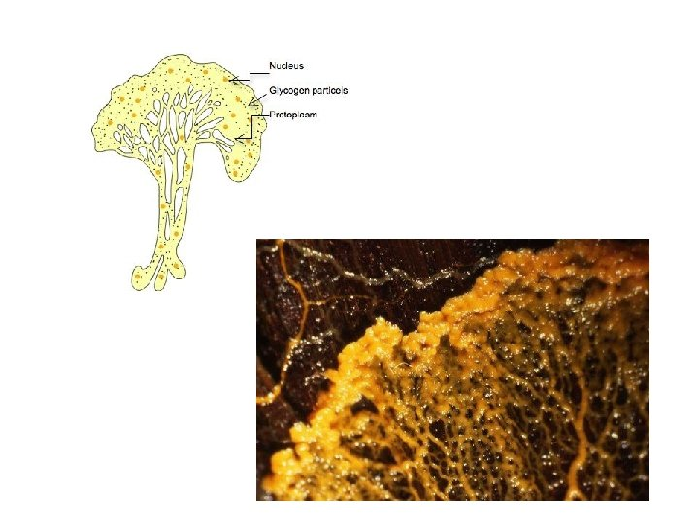

- Aphanoplasmodium
The aphanoplasmodium (Order Stemonitales) is characterized early in its development by a′ network of flattened, transparent threads, lack of polarity, and affinity for growing submerged in free water or under wet conditions. Young veins lack a distinct region of ectoplasm and endoplasm that facilitates movement through the interstices of decaying wood suddenly appearing overnight as hundreds of stalked sporangia in situ as in species of Stemonitis (Keller and Snell, 2002). Mature aphanoplasmodia on decaying leaves exhibit polarity and morphology typical of phaneroplasmodia and may migrate over short distances up to 10cm. Stemonitis flavogenita E. jahn in agar cultures migrates across the surface as immature stalked sporangia and, when fully mature, sporulates on the sides and lids of plastic Petri dishes (Keller, personal observations).

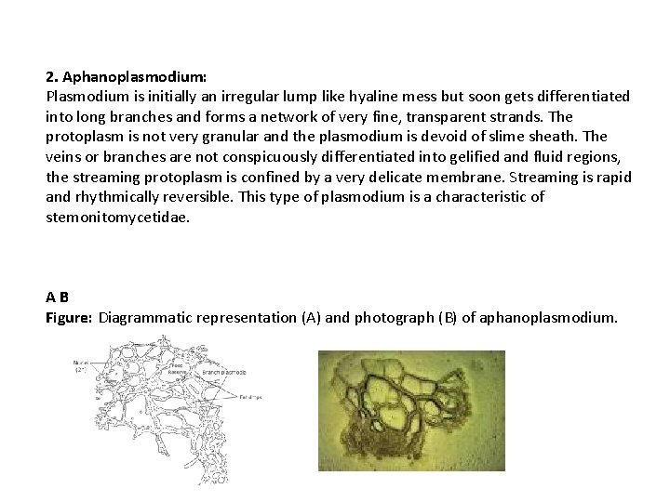

- Trichiaceous plasmodium

The trichiaceous plasmodium (Order Trichiales) combines morphological features′ of both the aphano- and phaneroplasmodial types. Perichaena depressa Lib. and P. quadrata T. Macbr. are examples of myxomycetes with this kind of plasmodium (Keller,1971; Keller and Eliasson, 1992). The anterior-posterior polarity of an advancing fan and trailing veins is established early in development. Although the advancing fan is the active growth center for forward movement, the mass of the plasmodium forms fruiting bodies in situ without migrating over long distances. Numerous fruiting bodies often develop from a single plasmodium on decaying wood or leaves, but not on living plants. The early stages of trichiaceous plasmodial development are extremely flattened and inconspicuous, and require free water in agar culture, otherwise sclerotization ensues.

TYPES OF FRUIT BODIES

Sporangium: sporangium is usually stalked and crowded or scattered on the substratum. Stalk varies in langth, size and colour. Sporangium is surrounded by Peridium and a thin hypothallus from which sporangium arise. Sometimes they are without stalk. For example: Stemonitis, Acryria, Comatricha etc

Aethelium: Aethelium are sessile, large or small, sometimes massive and cushion shaped. It is consist of several fused sporangia. The entire body is enclosed in a peridium. For example: species of Lycogala, Fugilo etc.

Plasmodiocarp: this type is sessile and branched, plasmodium like structure. During its development, the protoplasm of the plasmodium contracts around some of the veins and secretes a membrane around itself, forming the plasmodiocarp. For example: Species of Hemitrichia.

In some cases, a mixed type of fruiting body is noted. It is a mixture of sessile sporangia and plasmodiocarp. For example, Diderma testaceum.

